Multi-gap Resistive Plate Chambers: Time-of-Flight system of the PHENIX high-p_{T} Detector

Conceptual Design Report

June, 2005

J. Velkovska, T.Chujo, V.Greene, C. Maguire, H. Valle, D. Mukhopadhyay, D. Pal, I.Ojha, M. Velkovsky, M. Holmes, M. Mendenhall, J. Wallace

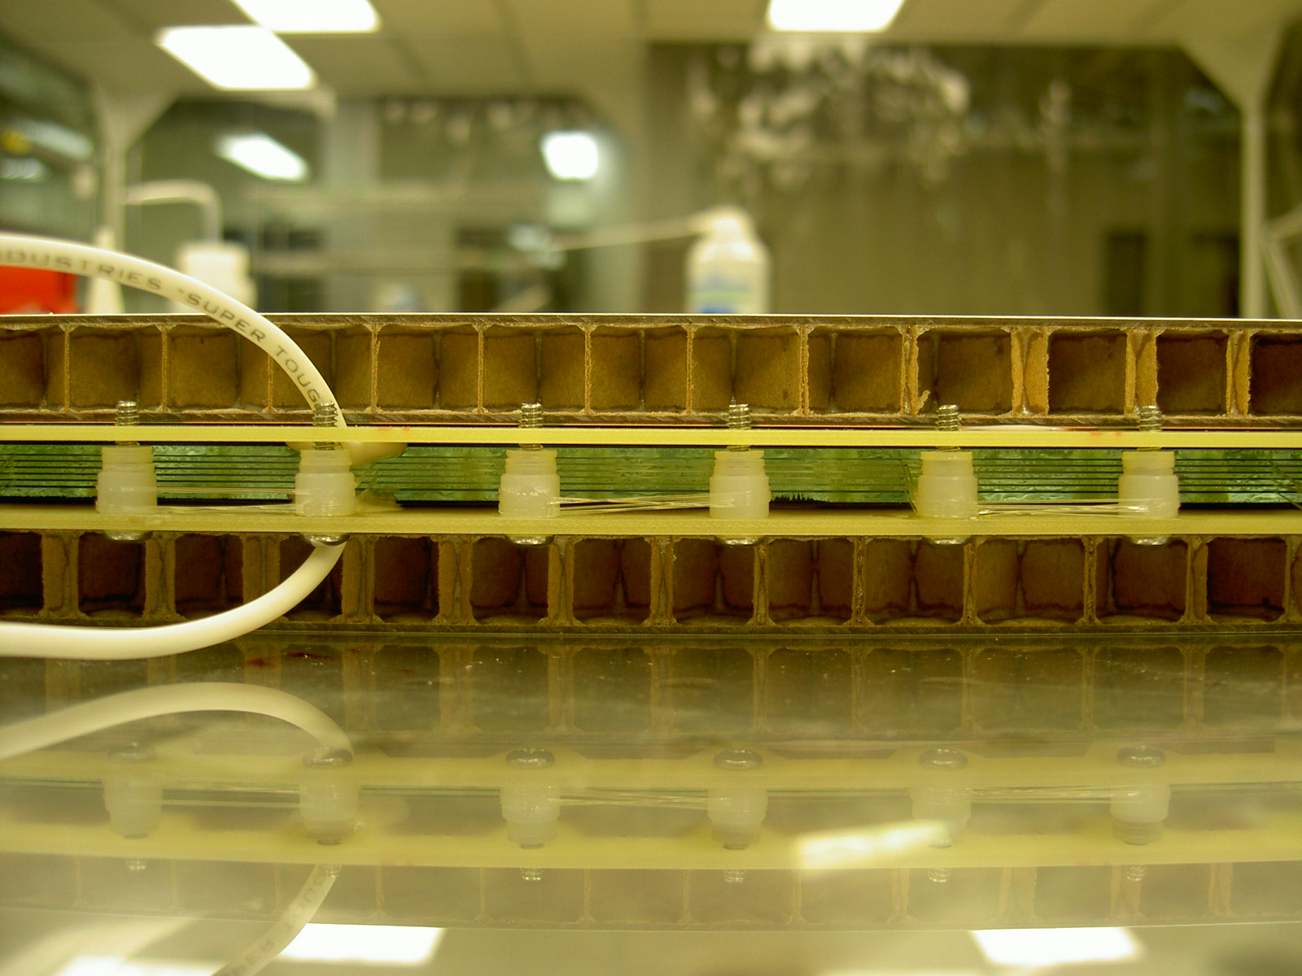

Contents:

Project Overview …………………………………………… 3

Physics Motivation .…………………………………………… 3

The PHENIX high-pt detector ……………………………… 7

Multi-gap Resistive Plate Chambers for PHENIX (R&D) …10
  - Overview of MRPCs in STAR and ALICE …………………. 10
  - Considerations for PHENIX. Prototype designs ………… 13
  - Test beam performance (KEK)…………………………… 19
  - Run 5 performance (Cu+Cu beam in PHENIX)……………..27

RUN5 goals ………………………………………………………28

Conceptual design of the full TOF-West system 29

Bugdet …………………………………………………………….29

Facilities and resources ………………………………………..31

Schedule …………………………………………………………..32

Acknowledgement ………….…………………………...33

Bibliography……………………………………………….33

Overview

In this Letter-of-Intent we propose to design and implement a cost - effective Time-of-Flight (TOF) detector for PHENIX, based on Multi-gap Resistive Plate chambers (MRPC). This detector will provide high-resolution timing measurement in the PHENIX West arm and together with the Aerogel Cerenkov Counters (ACC) will complete the planned high-p_{T} upgrade. The goal is to achieve timing resolution of ~ 100 ps, which will supplement the PID provided by ACC and the Ring Imaging Cerenkov Counter (RICH) and thus allow for continuous PID for pions, kaons and protons in the range 0.2 < p_{T} < 9 GeV/c. The complete system needs to be in place by RUN6 of RHIC, which is only a year away. This makes for a very aggressive schedule. Full use of previous worldwide R&D efforts, both in the detector construction and in the readout electronics are envisioned as the only possible path to success within the limited time available for this project. MRPC detectors have been the subject of extensive R&D for the ALICE experiment at the Large Hadron Collider and have already been implemented in the STAR detector at RHIC. The idea here is to make full use of these developments and, to a large extent, save the costly and time-consuming R&D. We are currently actively collaborating with the STAR TOF group at Rice University. This letter is organized as follows: Section 2 provides the physics motivation for this project; Section 3 outlines the role of the high-resolution TOF detector within the high-p_{T} detector. Section 4 describes the prototype MRPC development for PHENIX that was carried out at Vanderbilt University, the beam test performed at KEK, the results and the outstanding issues. Section 5 describes the prototype system proposed for installation in RUN5. Section 6 gives the conceptual design for the full system. Section 7 , 8 and 9 describe the cost of the project, the available facilities and resources and the schedule for completion.

2. Physics Motivation
We have witnessed exciting discoveries at RHIC. The suppression of high-p_{T} inclusive charged hadrons [1,2], π⁰ [1,3]  K_{s} [4] and the absorption of the away-side jets [5] are all consistent with “jet-quenching” as predicted [6] to appear with the presence of QGP. The measurements [7-10] in d+Au collisions showed beyond doubt that the observed effects in Au+Au collisions are due to the final state.

Figure 1 shows the PHENIX results obtained in sqrt(s) = 200 GeV Au+Au and d+Au collisions. The yields of neutral pions are measured in the two systems and compared to the yields obtained in p+p collisions (also measured by PHENIX [11]). The ratio of the yields in Au+Au collisions scaled appropriately to account for pure geometric factors and the yields in p+p collisions reveals a factor of ~5 suppression. The effect is not present in d+Au collisions. Initial state effects such as parton saturation [12] have been excluded as a possible explanation of the data

Figure 1. Nuclear modification factors for neutral pions produced in central Au+Au collisions or in d+Au collisions. A definitive test of “jet-quenching” has been provided.[7-10]

While hadron suppression was predicted by theory, the experimental results of
proton and anti-proton production [13] have revealed completely unexpected features. In central Au+Au collisions at relatively high-p_{T} ( 2 < p_{T} < 4 GeV/c) protons and anti-protons constitute almost half of the charged hadron yield contrary to the known jet fragmentation functions. However, their production scales with the number of nucleon collisions as expected for particles produced in hard-scattering processes, but not affected by the nuclear environment.

Figure 2. shows the proton/pion and anti-proton/pion ratios in three different centrality classes: 0-10%, 20-30%, and 60-92% of the total inelastic cross section. The ratios depend strongly on centrality indicating that the dominant production mechanism of protons and pions is centrality dependent at high-p_{T}.
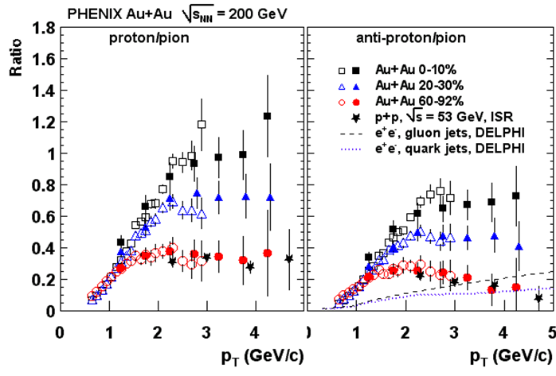
Figure 2: Proton/pion and anti-proton/pion ratios measured in Au+Au collisions at sqrt(s) = 200 GeV by PHENIX. Open (filled) points use charged or neutral pion data to form the ratio. For comparison, data obtained in lower energy p+p collisions and in e+e- collisions is also included.

The comparison with data obtained in lower energy p+p collisions and in e+e- collisions (included in the figure), shows that if both protons and pions are the products of hard-scattering, the fragmentation function in central Au+Au collisions must be rather different from that in peripheral collisions and in elementary systems. This result contradicts the common description of hard-scattering processes by a universal fragmentation function. An even bigger surprise is the result that the proton and anti-proton production is not suppressed at moderately high-pt. Figure 3. shows the comparison of the nuclear modification factors measured for pions, (proton+anti-proton)/2 and φ mesons. Above p_{T} = 2 GeV/c the measured baryon yield scales with N_{coll}, while meson production (π , φ ) is suppressed.
Figure 3: Nuclear modification factor for neutral pions, protons+anti-protons and φ mesons measured by the PHENIX experiment in sqrt(s) = 200 GeV.
Similar results have been obtained by the STAR experiment in the strange particle sector. Baryons and mesons show different behavior at moderately high-p_{T}. Only beyond p_{T} = 5 GeV/c, there is an indication that “normal” jet fragmentation returns. A number of exciting theoretical descriptions have attempted the explaination of the data. These include recombination of quarks from a thermalized system, the formation of an exotic gluonic configuration – the baryon junction or strong species dependent initial multiple scattering (Cronin effect). All of these theories call for significantly extended PID capabilities. This proposal aims at the development of a detector that will provide that.
Another observable that is sensitive to the early stages of the collisions and has brought most unexpected results in the identified particle sector is elliptic flow.
Elliptic flow at low-p_{T} is a collective effect. In the presence of bulk matter and strong pressure gradients, it transforms the initial anisotropy in position space (the ``almond'' of overlap between the nuclei) into momentum anisotropy. At high-p_{T}, azimuthal anisotropy can be generated by jet-quenching due to the different absorption along the short and long axes of the ``almond''. Elliptic flow is measured through the second Fourier component, v2, of the particle momentum
distributions with respect to the reaction plane. The maximum possible v2 at low-p_{T} is given by ideal (non-viscous) hydrodynamics. At high-p_{T} the limit is geometric and is maximal in the surface emission scenario, where partons traversing dense medium are completely absorbed due to large energy loss.

Hydrodynamics has been successful in describing low-p_{T} elliptic flow data both for inclusive and identified hadrons and the mass dependence
v2 (pion) > v2(Kaon) > v2(proton). At high-p_{T} the large, p_{T}-independent v2 measured for charged hadrons exhausts or even exceeds the limit of surface emission [14]. The measurements of elliptic flow with identified particles have shown deviations from the hydrodynamics description with the heavier particles protons and Λ decoupling at slightly higher p_{T} than the lighter ones (pions and kaons). At high-p_{T} v2 saturates, with the baryons carrying the largest signal. If this azimuthal anisotropy is due to energy loss, then it should also be reflected in larger suppression in R_{cp} contrary to the results presented above. Another puzzle has emerged. Recombination models have been proposed to resolve it [15].
On the experimental part, the availability of broad momentum range PID detector has become a necessity. This motivated the development of the PHENIX high-p_{T} detector.

3. The PHENIX high-p_{T} detector
The PHENIX high-p_{T} proton and anti-proton results have posed many difficult questions to the theory. Measurements of identified hadrons with p_{T} well above 5 GeV/c have become absolutely necessary. In the baseline configuration, PHENIX is equipped with a high-resolution TOF detector with timing resolution ~100 ps which gives pion, kaon and proton identification to moderately high-p_{T}. In addition, a Ring Imaging Cerenkov Counter operating with CO₂ gas with index of refraction n=1.00041 at 1 atm, gives charged pion identification for p_{T} >5.5 GeV/c. A Cerenkov detector with index of refraction n = 1.01 can fill the gaps in PID that are left between the TOF and RICH. Such detector was designed and built as part of the PHENIX upgrade program.

The additional Cerenkov counter is based on aerogel, which is a silicon-based solid with a porous, sponge-like structure in which 99 percent of the volume is air. It is one of the least dense solids known. Aerogel has attracted much interest as a Cerenkov radiator because it is a solid but has index of refraction smaller that most liquids and solids (only liquid He is close), but larger than gasses at atmospheric pressure.

The PHENIX Aerogel Cerenkov Counter consists of 160 elements of hydrophobic aerogel covering 1 sector, Δ φ = 14 º in azimuth and |Δ η | < 0.35, in the West arm of PHENIX (Figure 4). In combination with a high-resolution TOF detector and the already existing RICH, PID can be achieved up to p _{T} ~ 9 GeV/c for pions, kaons, protons and anti-protons. This will allow for a crucial test of quark-recombination and baryon junction models above p _{T} = 5 GeV/c.

Figure 4. The Aerogel detector installed between Pad Chamber 2 (PC2) and 3 (PC3) in the W1 sector of the PHENIX West Central Arm.

Figure 5. The Aerogel detector structure and the orientation with respect to the beam line are shown. The yellow boxes represent the aerogel volumes. The green tubes are the PMTs arranged to minimize dead areas. The red boxes represent the support structure.

Figure 6. PID scheme using the combination of TOF, RICH and ACC. For each detector, the red lines indicate the region of transverse momentum in which particle separation is achieved.

Figure 6 illustrates the PID scheme using the combination of TOF, RICH and ACC. For each detector, the red lines indicate the region of transverse momentum in which particle separation is achieved. The TOF detector (with resolution σ ∼100 ps) provides a 4 σ π/K and K/p separation up to p_{T} 2.5 and 4.5 GeV/c, respectively. The RICH detector gives pion identification above p_{T} 5.5 GeV/c. The ACC turns on for pions at p_{T} = 1 GeV/c and for kaons - at p_{T} = 5 GeV/c,thus filling the gap in π/K separation in the region 2.5 < p_{T} < 5 GeV/c, where neither RICH nor TOF can separate pions from kaons. ACC also provides K/p discrimination for p _{T} > 5 GeV/c, where TOF identification is no longer possible.

In Run4, timing information for low-p_{T} PID was provided from the Pb-Scintillator electromagnetic calorimeter, which has timing resolution of σ ~ 450 ps. This is significantly worse than the required resolution needed to achieve seamless PID for π,K,p up to p_{T} = 9 GeV/c. In this configuration, pion identification is unaffected, but kaon and proton PID is significantly reduced. Kaons can not be identified in the region 2 < p _{T} < 5 GeV/c. A similar PID gap exists for protons. We note that this is the region where recombination is expected to dominate. It is clear that without a high-resolution TOF detector, the continuous PID coverage and many of the physics goals for the high-p_{T} detector are compromised.

The Vanderbilt group is proposing to build a high resolution TOF detector in the West arm of PHENIX. We investigated Multi-gap Resistive Plate Chamber (MRPC) technology. Start-up funds, provided by Vanderbilt University to Prof. Velkovska were used for prototype development. A proposal to develop such a system for PHENIX was submitted to DOE and was granted an Outstanding Junior Investigator award in the competition for year 2004. This is one out of 3 nationwide grants that were awarded this year. Funds from the OJI award will be used to cover ½ post-doc salary and the purchase of equipment necessary for the MRPC chamber and electronics test stands at Vanderbilt.

4. MRPCs R&D studies
4. a Overview of MRPCs in ALICE and STAR.

MRPCs have been implemented successfully in the STAR detector [16] and are being built for the STAR large area TOF upgrade [17]. They are also being implemented by the ALICE experiment [18] at the Large Hadron Collider - CERN. A vast amount of costly and time-consuming R&D work has already been done in this direction by the ALICE and STAR collaborations. Our approach has been to build on existing technology and work in close collaboration with the STAR TOF group. We have done our own R&D studies which are aimed to match the PHENIX detector resolution, occupancy and electronics requirements. In this section, we give an overview of the worldwide MRPC studies. The PHENIX R&D results are discussed in Sections 4.b and 4.c .
Two types of MRPCs have been investigated in the course of the ALICE R&D development: single stack and double stack. A schematic view in the two cases is shown in Figure 7. In both cases, the detector consists of a stack of resistive plates (float glass), spaced from one another with equal sized spacers creating a series of gas gaps. Monofilament fishing line is used as spacers. Electrodes (carbon tape) are connected to the outer surfaces of the stack of resistive plates, while the internal plates are left electrically floating. The signals are imaged on copper pick-up pads. In the double stack design, two MRPCs are built on each side of the anode pick-up pads. The advantages in this configuration are larger signals, reduction in the required HV, anode and cathode can be moved closer which makes the footprint of the avalanche smaller and thus sharpens the pad boundaries. In the final design, ALICE uses 10 gap double stack MRPCs. The chambers have active area of 7x120 cm² and are readout by pads with area 3.5x2.5 cm².

From the point of view of performance, the single stack design is comparable to the double stack design as illustrated in Figure 8 and Figure 9.

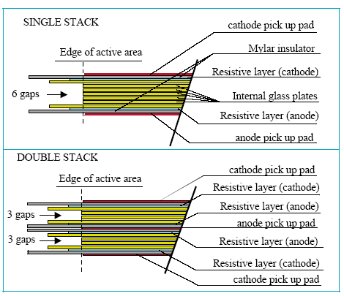

Figure 7. MRPC designs investigated for ALICE (figure taken from ref. [18]).

A single stack 6 gap configuration was chosen for STAR with outer glass thickness 1.1cm, inner glass – 0.55cm and gap size – 220 μm. This design is simpler than the double stack and although it has slightly worse resolution and efficiency, the STAR collaboration has found that the performance is satisfactory. The pick-up pads have dimensions 3.15cm x 6 cm. The chambers have active area 20 cm x 6 cm. The read-out is single ended. The PCB layout with the six read-out pads is shown in Figure 10. Full 2π azymuthal coverage at a radial distance of 2 m is envisioned and currently under construction. Figure 11 shows the typical performance plot for the STAR MRPCs. The resolution quoted is obtained after slewing corrections and subtraction (in quadrature) of the start time resolution, which is measured independently. These results were obtained with gas mixture 90%/5%/5% C₂H₂F₄ (Freon R134a), i-C₄H₁₀, SF₆. The SF₆ is used to quench streamers and allows safe operation at voltages > 15 kV.

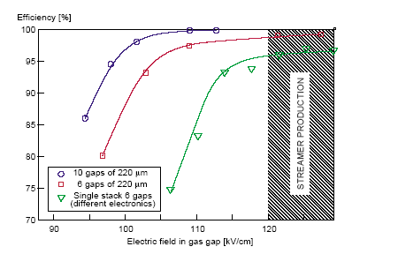
Figure 8. Efficiency as a function of electric field strength for double stack (10 gaps) and single stack (6 gaps) MRPC tested by ALICE group [ ref.18.].

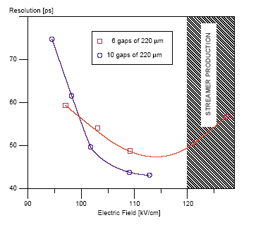
Figure 9. Comparison of timing resolution of single stack and double stack MRPC researched fro ALICE (figure from ref.[18]).

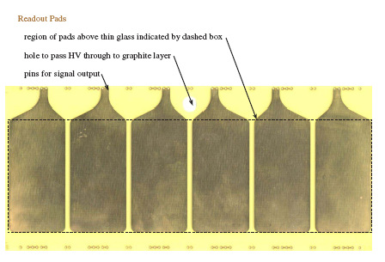
Figure 10. Read-out configuration (PCB) of the STAR MRPC detectors (from ref.[18]).The active area (dashed line) is 20 cm x 6 cm; pad size - 3.15 cm x 6 cm; pad spacing - 3 mm.

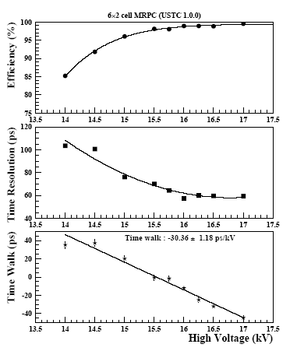

Figure 11. The detection efficiency (upper frame), slewing-corrected time resolution (middle frame), and time walk (lower frame), as a function of high voltage for the 6 gap MRPC implemented for the STAR upgrade. (the figure is from ref. [17]). These results were obtained with gas mixture 90%/5%/5% C₂H₂F₄ (Freon R134a), i-C₄H₁₀, SF₆. The SF₆ is used to quench streamers and allows safe operation at voltages > 15 kV.

4. b Considerations for PHENIX. Prototype designs. KEK test.

Several factors have played a role in designing the PHENIX MRPC prototypes. The aggressive schedule has certainly biased us towards simpler solutions. The success of the STAR MRPC detector tests has influenced our decision to implement a single stack design with 6 gaps. Below we describe all other design parameters that are important for the performance and justify our choice for the PHENIX prototypes.
- Thickness of inner and outer glass:
The thickness of the glass together with the gap sizes determines the electric field strength in the gaps. We followed the STAR design in choosing this parameter: 0.55mm for the inner glass and 1.1mm for the outer glass. This choice was also bound to the sizes that were available from Precision Glass and Optics.
- Gap size:
The sensitivity to the gap size is not significant. The bigger gap sizes reduce the electric field strength (for the same voltage applied), but at the same time the avalanches are allowed to grow longer – hence the overall gain is not affected. Figure 12 demonstrates the performance of 6 gap MRPCs tested for ALICE using different gap sizes. Varying the gap from 280 μm to 220 μm does not influence the performance in the voltage plateau region. We have chosen 230 μm gaps. Monofilament fishing line is used for spacers.

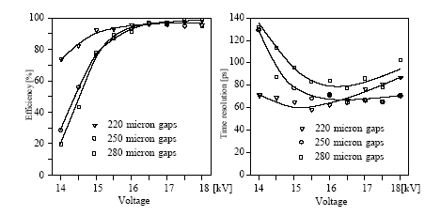
Figure 12. ALICE R&D plot from [17] shows the efficiency and resolution as a function of HV for single stack 6 gap MRPCs with different gap sizes.
- Gas mixture:
The gas mixture used by ALICE is 90%/5%/5% C₂H₂F₄ (Freon R134a), i-C₄H₁₀, SF₆. Since SF₆ is a ODH (oxygen deficiency hazard) gas, the STAR detectors use a two component mixture: 95%/5% C₂H₂F₄ (Freon R134a), i-C₄H₁₀. The SF₆ gas is important for the performance, since it quenches the streamers and allows streamer-free operation at higher voltages and thus improves the efficiency and the resolution of the MRPC. With the two-component mixture, the resolution is 80-100 ps and the typical efficiency is of the order of 95%. This is to be compared to 60ps and >95% efficiency shown in Figure 11, where a 3-component gas mixture was used.

Chamber size:
Our original intent was to cover the active area behind the aerogel detector in the W1 sector, which is 4m x 1.20 m. This is less than the active area of the pad chambers PC2 and PC3. The goal was to minimize the number of readout channels and MPPC chambers. In this case, it is desirable to work with larger chambers and arrange them in two rows along the y-direction. We tried to build the biggest chambers that could fit in the space available and use the regular stock sizes of the glass sheets supplied by Precision Glass and Optics.

The inner glass (0.55 mm thickness) is available in sheets 20” x 20”. Our prototype PH1 was designed as a square chamber using the above glass size. As shown above, the ALICE and the STAR MRPCs have very different dimensions. STAR uses really small chambers (inner glass 20x6 cm²). ALICE has long and narrow chambers: 120 x 7 cm². Coming up with squares: 53.3 x 53.3 cm² seemed like a big departure from the already researched designs. Concerns about being able to control the uniformity of the gas gaps and HV lead to making prototype chamber that is ¼ size of PH1. We built 2 different ¼ size prototypes: PH2 and PH3 that have the same glass dimensions, but different readout configuration.
- Readout pads/strips.
The idea is to use a configuration which is as close as possible to TOF East, so that we have similar occupancy and readout configuration. Strips with double ended readout were implemented for PH1 and PH2. The layout of the strips used in for PH1 is shown in Figure 13. The timing information is obtained using the average time measured at both ends of the strip. The position information along the strip is determined using the measured time difference. Figure 14 shows the readout configuration for PH2 and PH3. Since both STAR and ALICE use 3 mm gaps between pads to prevent cross talk, we made our strips 1.3 mm wide with 3 mm separation gap between them. The length of the active area is determined by the size of the inner glass (53.3 mm). These sizes are to be compared to the area of the TOF slats : 1.5x64 cm² and 1.5 x 42 cm². Hence, for PH1 and PH2 we expect occupancy <10% in central Au+Au. The number of strips was also chosen so that we have readout channels in multiples of 16 in order to match the segmentation of the TOF FEMs. PH1 has 32 strips (4 FEM modules), while PH2 has 8 strips (1 FEM module).
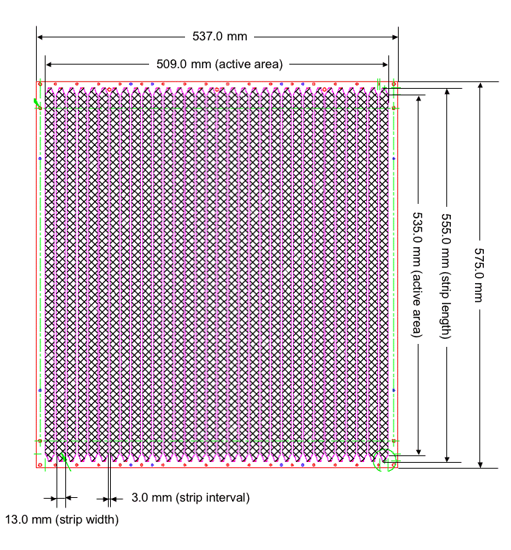
Figure 13. Pick-up PCB configuration in PHENIX prototype 1 (PH1). 32 strips are read out from both ends to determine the time and position of the charged avalanches produced by particles traversing the detector.

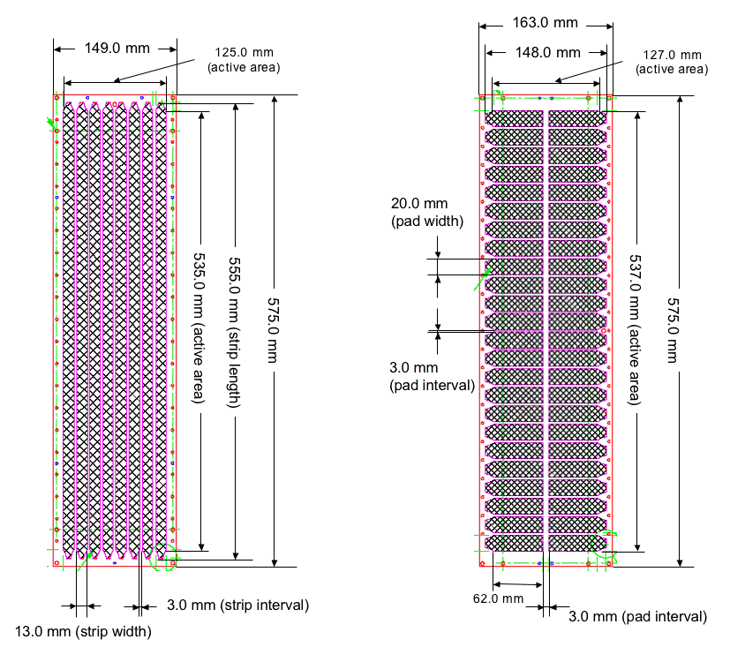

Figure 14. Pick-up PCB layout for PHENIX prototypes 2 and 3. PH2 is shown on the left and PH3 is on the right. PH2 is ¼ of the size of PH1. PH3 has the same dimensions as PH2, but is read out by pads.

Since neither STAR nor ALICE has implemented strip readout, and there was a concern that large capacitance in the strips will ruin the good timing resolution, we decided to make one prototype that follows more closely their design. We wanted to keep the other parameters the same as for PH2, but to make a single ended read out using pads. Keeping the number of channels in multiples of 16 was another factor that played in choosing the number of pads in PH3. As shown in Figure 14, PH3 has 48 readout pads with dimensions 2 x 6.2 cm² . This configuration, of course, increases the number of electronics channels by a factor of 3, which is a significant part of the cost of the whole system. It was desirable, in case of similar performance, to use PH2 instead of PH3.

The cross sectional view for the PHENIX MRPC (PH2) is shown in Figure 15. The sizes of all components are shown in the figure.

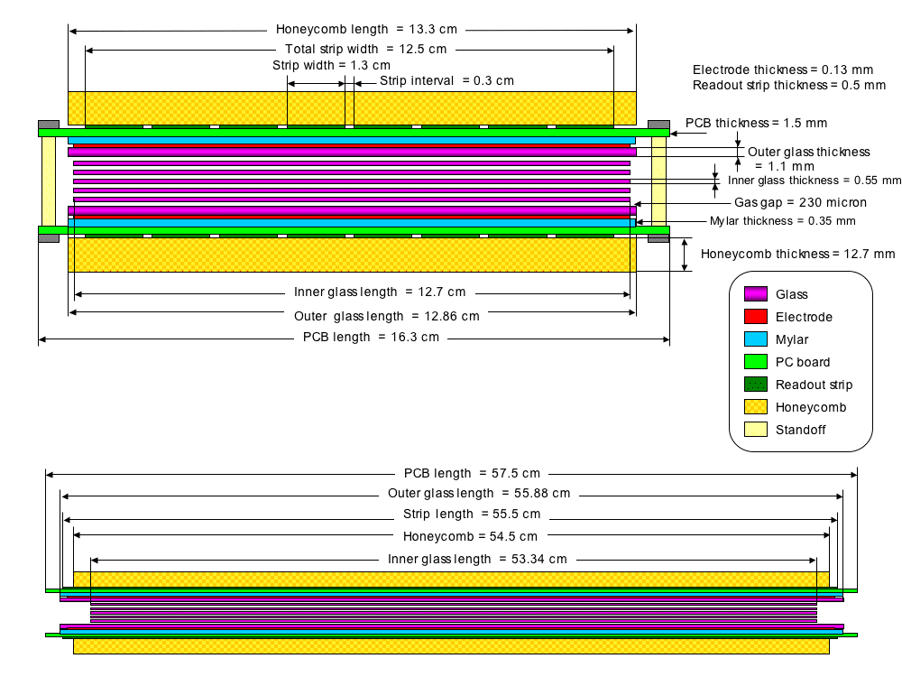

Figure 15. Cross sectional view showing all component sizes for the PH2 design.

The three MRPC prototypes were tested at KEK (High Energy Accelerator Research Organization), in Tsukuba, Japan in June 2004. We used secondary beams produced by the internal target in 12 GeV Proton Synchrotron. The beams were extracted to the experimental area, called T1 beam line. Positively charged particles with momentum of 2 GeV/c were used for this test. The beam consisted mainly of pions and protons (about 50%/50%). A small amount of deuterons and kaons were also identified.

A schematic view of the experimental setup is shown in Figure 16. Figure 17 shows a photograph of the setup with the different elements labeled in the picture. Three plastic scintillation counters (ST1, ST2, and ST3) which were read out by the photo-multiplier tubes at the both ends were used to obtain the start time information. The combination of 3 counters also allows the independent measurement of the resolution of the start time signal.The dimension of scintillation counter is 5x5 cm2 for ST1, and 2x2 cm2 for ST2 and ST3. Each counter has an intrinsic timing resolution of about 50 psec. Two defining counters, (DEF1 and DEF2, 1x1 cm2 each) were used to define the beam position. A VETO counter was used to reject background. The VETO counter was a large area scintillation counter (10x20 cm²) that had a 1 cm diameter hole in the center. The hole was aligned with the defining counters. The beam trigger was determined by requiring a coincidence of ST1&ST2&ST3&DEF1&DEF2 and anti-coincidence with the VETO. The trigger rate was about 20 counts per beam spill, and the duration of spill is 2 sec. The MRPC was located 3 m away from the first start timing counter (ST1). Figures 16 and 17 also show a Time Projection Chamber (TPC) and an Electromagnetic Calorimeter (EMC) located downstream from the MRPC. These were part of a test performed by the Tsukuba group and were not used in this analysis.

The signals from the MRPC were pre-amplified and discriminated on boards that were positioned directly on the gas box. These are visible in Figure 17. The pre-amp boards were borrowed from Bill Llope from Rice University . These were originally used in the STAR test set-up. The signal from the pads is amplified by Maxim 3760 fast current amplifier, then amplified in a second stage to produce output into 50 Ω. The discriminator is based on the AD96685 comparator. The outputs from the amplifier and discriminator were connected to CAMAC ADC and TDC modules, respectively. The TDCs had 25 ps/channel and were operated in a COMMON START mode. The COMMON START signal was provided from the trigger signal described above. The individual MRPC strip or pad signals were used as STOP signals for the TDC channels.

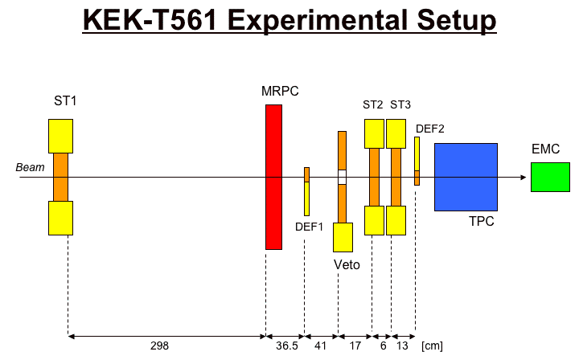
Figure 16. A schematic view of the experimental set-up used for the beam test of the MRPC prototypes. Scintillator counters ST1, ST2 and ST3 are used to provide start timing information. DEF1, DEF2 are small-area scintillator counters used to define the beam position. Veto counter is used for background rejection
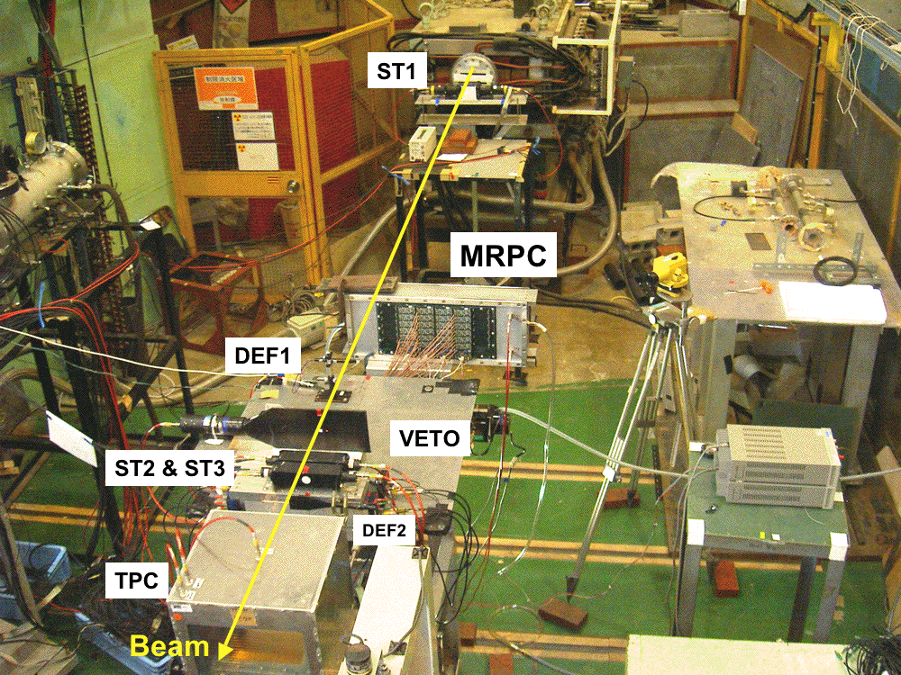
Figure 17. A photograph of the experimental set-up. The components for the test are labeled.
The following measurements were performed and the results were evaluated by comparing the timing resolution and the efficiency under the different conditions:
- Voltage scans
- Horizontal and vertical position scans
  - Across chamber
  - Within a pad
- Discriminator threshold scan (best results were obtained with the lowest threshold)
- Gas mixture (nominal: R134a/C4H10 95%/5%, 1cc/sec
  - 97%/3% (+/- 0.5%)
  - 92%/8% (+/- 0.5%)
  - Flow rate x 2
- Charge distribution (cross-talk)
- Streamer rate study (normally operate in avalanche mode)
- Electronics test – (use on-board discriminator or discriminate the analog signal as coming from the pre-amp boards.)
Figures 18,19, and 20 show performance plots for PH1,PH2 and PH3, respectively. These plots were obtained from the runs used in the voltage scans that are summarized in Figures 21 and 22. Plots for all runs are available at:
http://www.hep.vanderbilt.edu/~chujo/MRPC/KEK_ana/04.0701/fig/
The data analysis of the KEK test data has been documented in an electronics logbook that is available for public viewing at:
http://vpac01.phy.vanderbilt.edu:8080/KEKdata/

The top left plots in the performance figures (Fig 18,19,20 ) show the TDC distribution of the average time obtained by ST2&ST3 with the time of ST1 subtracted. Two main peaks are visible: pions on the left and protons on the right. The small shoulder at the high end of the pion peak is due to kaons admixed with the main beam particles. A small deuteron peak is also present.
The analysis was carried on with identified particles, since we wanted to know if the detector has uniform response to different particle species. The PID selection was done based on the top left plot. The top middle and top right plots show the timing distribution obtained from the MRPC using either ST1 or ST2&ST3 as a start time signal. Using the information from all three top plots, the intrinsic timing resolution of ST1, ST2&ST3 and the MRPC can be extracted separately. The MRPC results shown in the top plots are corrected for slewing. The slewing effect and the functions used for the correction are shown in the two bottom plots. There are two distinct peaks in the ADC distributions. The lower one is produced in avalanche mode, which is the normal operational mode of the MRPC. The top one is due to streamers, the percentage of which increases with the increase of the high voltage. The streamers have worse resolution (about 100 ps) and a larger charge footprint. Studies of hits in neighboring pads (done with PH3 when the beam is positioned in the center of the pad) show that in almost 100% of the cases these hit occur when the main pad develops a streamer. In the case of PH1 and PH2, we found that the strips are not wide enough to contain the charge footprint and hits were registered on the side strips even if no streamers were produced. The plots contain information about the HV setting, the channel in which the main hit occurred, the discriminator threshold setting, the PID of the particle for which the numbers were derived, the efficiency, the intrinsic timing resolution of the MRPC and the start counters, the ADC fit range that was used to determine the slewing corrections, the percentage of hits that were due to streamers, the timing resolution of the MRPC (using ST1 as a start timer) after the slewing correction, but before subtraction the resolution of the start counter; the same quantity in the case of streamers.

Figures 21 and 22 summarize the timing resolution and efficiency results obtained from the voltage scan of the three prototypes. The two small chambers PH2 and PH3 show excellent timing resolution. We are particularly pleased that with the strip design (PH2) we achieved σ ~ 70 ps. These results are comparable to the results obtained by STAR with much smaller chambers and using pad readout (see Figure 11). The results from our pad design (PH3) are slightly worse concerning the timing resolution in this voltage scan. We have however observed that overall (from all runs with varying conditions), the performance of the pad design was a bit better. We must, however, take into account that in the case of the strip design, we can determine the position of the hit using the timing measurements alone. In the case of the pads, the test beam was well defined (within 1 cm²) due to the defining counters. On carriage, we can not define the hit position with such accuracy, even if we use information from the tracking detectors. As a result, the timing measurement will be subject to smearing due to the spread in hit positions. Compared to PH2 and PH3, the resolution of the large chamber (PH1) was poor and to a large extent non-uniform across the detector. It is also apparent in Figure 17 that the gain in the particular channel shown in the figure is smaller than for the gain in PH2 and PH3. We attribute these observations to non-uniformities in the gas gaps that were very difficult to control in the big square chambers due to the larger weight of the glass and the lack of binding in the layers of glass and PCBs in the middle of the detector. It may be in principle possible using engineering analysis to make a better design for a square chamber in which the gas gaps are under control. However due to lack of R&D time, we decided to abandon this design and continue the development with the ¼ size chambers.

The pad design (PH3) showed excellent detection efficiency (Fig. 22) ε = 95%. The efficiency for both strip designs is ~ 90%. This value is lower than what we would like to have in our final implementation and we need to understand why the efficiency in bith PH1 and PH2 is smaller than for PH3. One obvious difference in the designs is the width of the pads/strips. The smaller side of the pads is 2 cm wide, while the strips are only 1.3 cm wide. We notice that both STAR and ALICE use pads that are wider (3 x 6 cm² and 2.5 x 3.5 cm²).
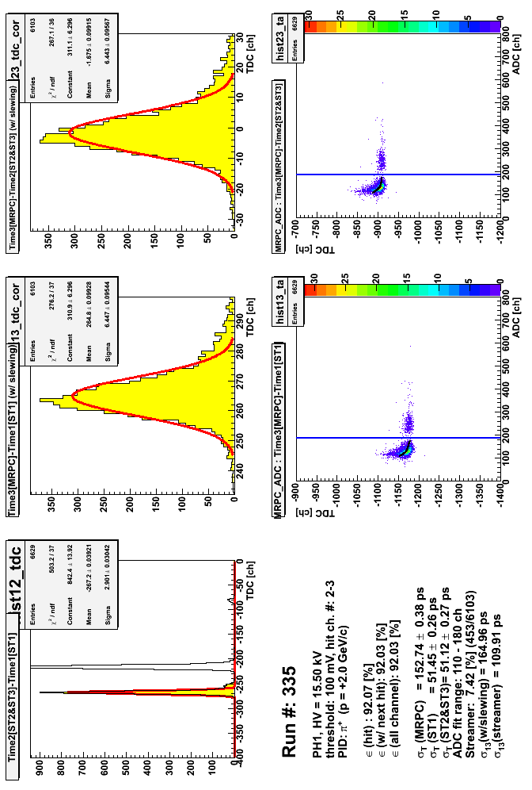Figure 18. Performance plot for PH1. The plots in the different panels are explained in the text.
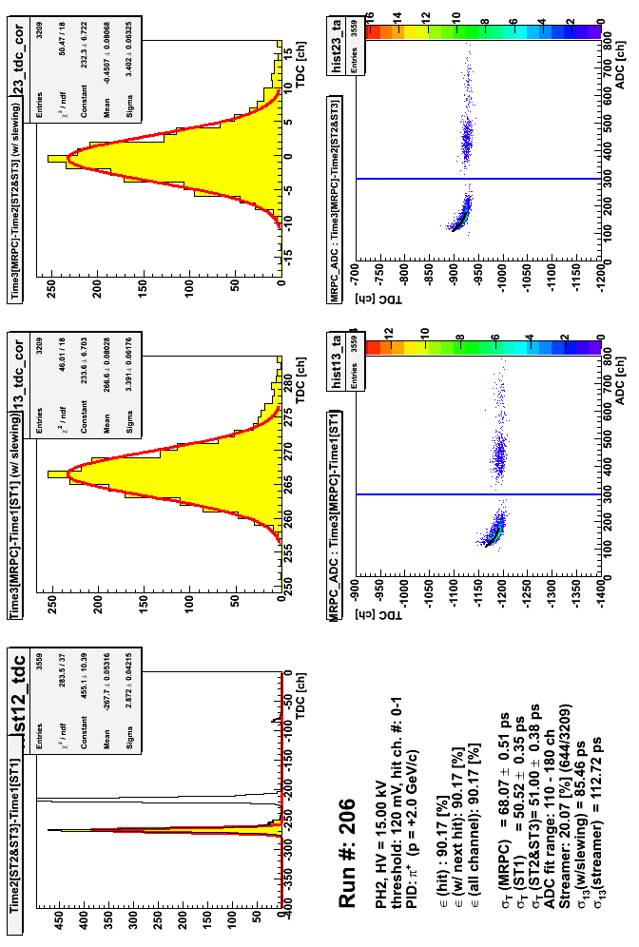

Figure 19. Performance plot for PH2. The plots in the different panels are explained in the tex.t

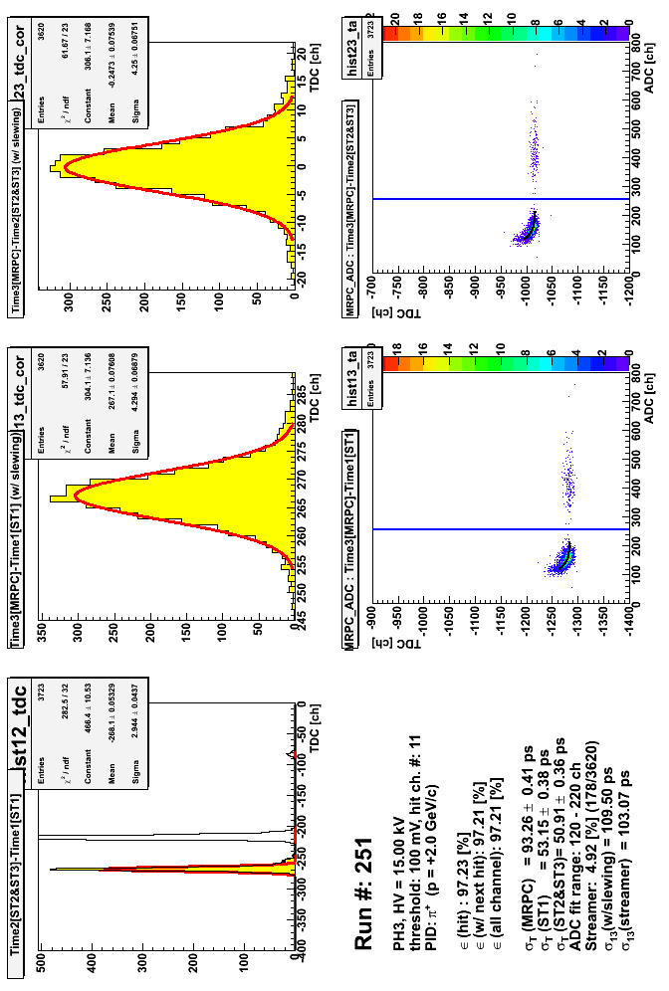Figure 20. Performance plot for PH3. The plots in the different panels are explained in the text.

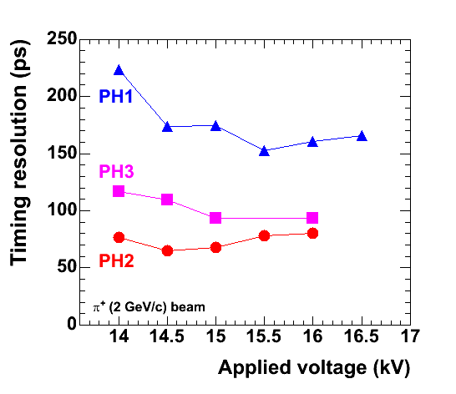

Figure 21. Timing resolution for the three prototypes as a function of the applied high voltage
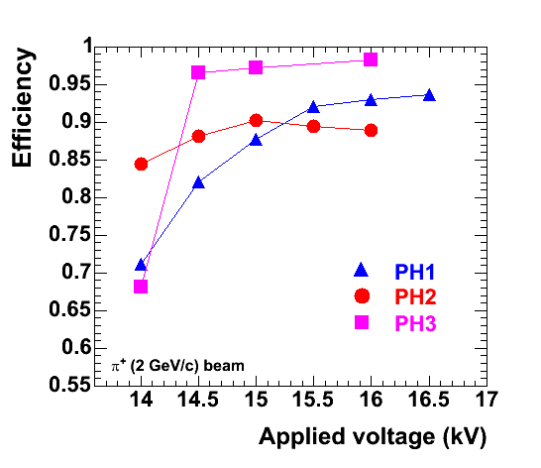
Figure 22. Efficiency for the three prototypes as a function of the applied high voltage
We performed horizontal and vertical scans along and across the strips/pads in order to study boundary effects. Uniform response was found along the strips of PH2. However across the width of the strips this was not the case. The efficiency varies depending on the position We found that the charge footprint is ~ 2.5 cm in diameter and that our choice of 1.3 cm wide strips is probably the cause of the reduced efficiency in PH1 and PH2. Since the charge gets split between two strips, it sometimes remains under the discriminator threshold and does not produce a hit. Figure 23 shows the horizontal scan across the pads of PH3. The efficiency registered in each pad is used as a measure for the extent of the charge distribution. The three pads are shown in different colors. The x-axis is shows the position of the hit (in cm). The efficiency across the pads has a nice high-efficiency plateau and then drops at the boundaries (but it may also fire the neighboring strip, so the hit is not completely lost). In the case of streamers, though, double hits do occur even if the beam is positioned at the middle of the strip. This is due to the wider charge footprint.
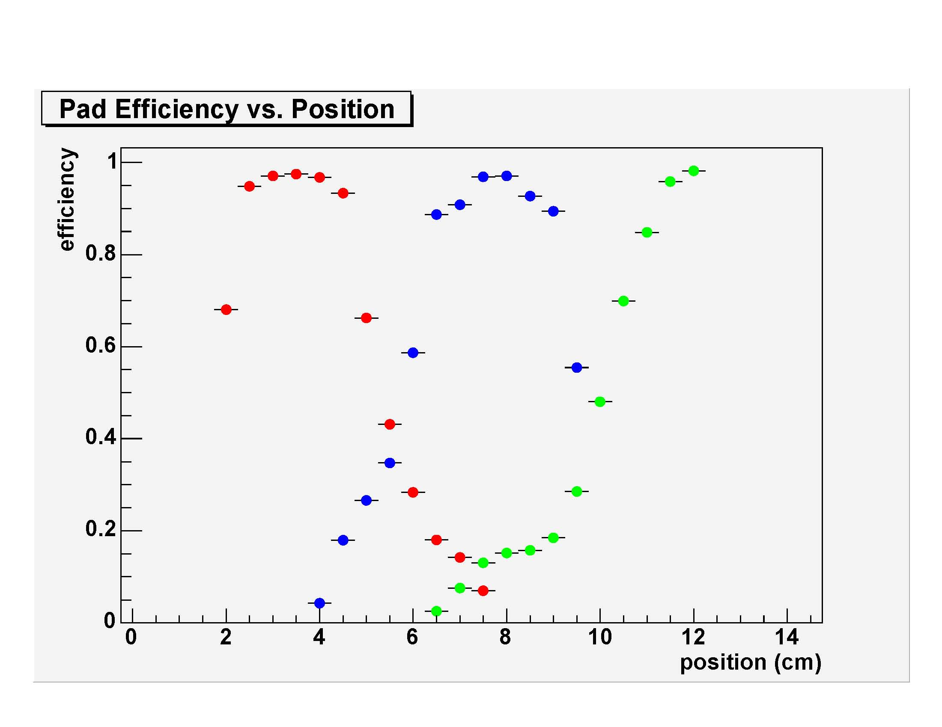
Figure 23. Horizontal scan across the pads of PH3.The efficiency as a function of hit position is shown.

The rest of the parameters studied, like gas flow rate, gas mixture etc did not have a significant impact on the MRPC performance. This means that the we can operate with a 2 component gas system and that it can have relatively relaxed tolerances on the exact Freon- isobutane mixiture.

5. R&D studies using heavy ion beams in PHENIX - Run 5 .

Three major goals were set for RUN5 :

- To investigate ways to improve the efficiency in the strip read-out design, while still running with a 2 component gas mixture. Wider strips were considered as a way to better contain the charge distribution and thus improve the efficiency. A new prototype with double –ended strip readout (PH4 shown in Figure 24) and 2 cm wide strips was built and operated during Run 5
- To build and test a complete electronics chain that operates with the PHENIX data acquisition system (DAQ).
- To evaluate of the performance of the different MRPC designs under heavy ion beam conditions.

5.a Run 5 set-up
Two identical gas boxes were installed in sector 0 in the West arm of PHENIX. The boxes contained the new PH4 chambers along with the already tested PH2 and PH3, which were included in the test to facilitate a fair comparison of performance under the conditions of heavy ion beams. Figure 25 shows a schematic view of the set-up showing the position of the read-out strips/pads (bottom of Figure 25). The top two photographs (Figure 25, top) show the detectors already installed on carriage. The prototypes were successfully operated for the entire duration of the Cu+Cu run. The low voltage, high voltage and DAQ chain were also successfully commissioned.

5.b Run 5 electronics R&D.

For the KEK test, we used pre-amplifier/discriminator boards designed for the STAR MRPCs at RICE University and used by STAR during RUN3. In the STAR documents, these are referred to as the FEE boards. Mechanically, these electronics consist of two layers of circuit boards. The "lower" level is the Feed-through boards (F/T). These gas-seal and faraday-cage the MRPC gas volume,and pass the MRPC signals out of the gas box and to the "upper layer", which are the "FEE" boards. The F/T boards do nothing more but complete the faraday cage about the MRPCs and pass the signals using IDC-style pin headers. These boards are very sparse in terms of components and do not require low voltage. Bleeder resistors are used on these boards to prevent pads from charging up if the FEE boards are not connected.
The FEE boards used in the KEK test have two outputs per MRPC readout channel. One is a amplified copy of the original input signal (for digitization in an ADC), and the other is a NIM-standard logic signal (for a TDC).
The FEE board contains both pre-amplificiation and amplificiation of the MRPC signals. The preamp device, a Maxim 3760, is a low-noise-input trans-impedance integrated circuit whose gain and rise-time characteristics are well-defined by internal feedback. This part is commercially available for use as a photodiode receiver preamp in data communication applications. Several designs employing this chip have shown excellent timing performance when connected to actual MRPC pads - the Maxim 3760 has been used extensively for the past three years by both the STAR and ALICE TOF groups. An AD8001 is used as the amplifier. An ultra-high speed integrated circuit comparator, the AD96685, serves as a simple leading-edge discriminator with externally controlled threshold. This circuit has also been demonstrated successfully in the several generations of STAR TOFr systems.
During the KEK test, we use CAMAC ADCs and TDCs to record the signals from the MRPCs. We were able to obtain excellent timing resolution using the on-board discriminator and a CAMAC TDC. However, the CAMAC readout, although shown to work, is not compatible with the PHENIX DAQ, which is designed for a large scale experiment. It is desirable to use one of the already developed Front End Modules (FEMs) to interface the pre-amplifier boards to the data collection modules (DCMs) and to communicate with the timing and trigger systems. We would like to use the TOF FEMs developed for the scintillator-TOF installed in the East arm of PHENIX. But we can not just replace the CAMAC modules with the TOF FEM. The difference is that the TOF FEMs accept analog signal only and then discriminate it within the FEM. This requires that the analog signal out of the pre-amp has a well defined timing edge, but the amplifiers in the RICE boards were not optimized to allow a good timing measurement using the analog signal.

For our R&D studies in RUN5, the RICE group produced 5 different modifications to their original (RUN3) boards. These were tested on the bench at Nevis laboratory and with cosmic rays. The modifications included:

(1) Channel 1:
modified feedback and compensation to
increase the bandwidth of the amplifier "a lot".
the leading edge is now faster (steeper) than before.
Pulse hight increase: factor 2.
Saturate ~350 mV.

(2) Channel 2:
same as channel 1, except comparator
is disabled, which doubles the pulse height on
the analog output.
Pulse hight increase: factor 3-4.

(3) Channel 3:
modified feedback and compensation to
increase the bandwidth of the amplifier, but
not as much as for channel 1.
Pulse hight increase: factor 2.

(4) Channel 4:
same as channel 3, except comparator
is disabled, which doubles the pulse height on
the analog putput.
Pulse hight increase: factor 4

(5) Channel 5:
same as channel 1, but source back
termination resistor removed. analog output still
drives a 50 Ohm cable & load, but analog
pulse height is double the height compared to
channel 1.
Pulse hight increase: factor 4

(6) Channel 6:
no change.

Configuration (5) was chosen for RUN5 electronics. Scope traces comparing the analog and digital results from (5) compared to the original (6) are shown in Figure 26. Further documentation of the pre-amp test can be found at:

https://www.phenix.bnl.gov/WWW/p/draft/chujo/MRPC/publish/preamp_test_04.0819/

The RICE group produced a total of 40 boards to be used in RUN5. The FEMs for RUN5 were spares from TOF.E , plus – we borrowed 4 FEM boards that were connected to slats at the edge of the fiducial area. The goal was to obtain a reliable test the electronics that is decoupled from the detector tests. We instrumented 128 analog output channels and 64 digital outputs. The analog vs digital readout was successfully tested (see the results section).

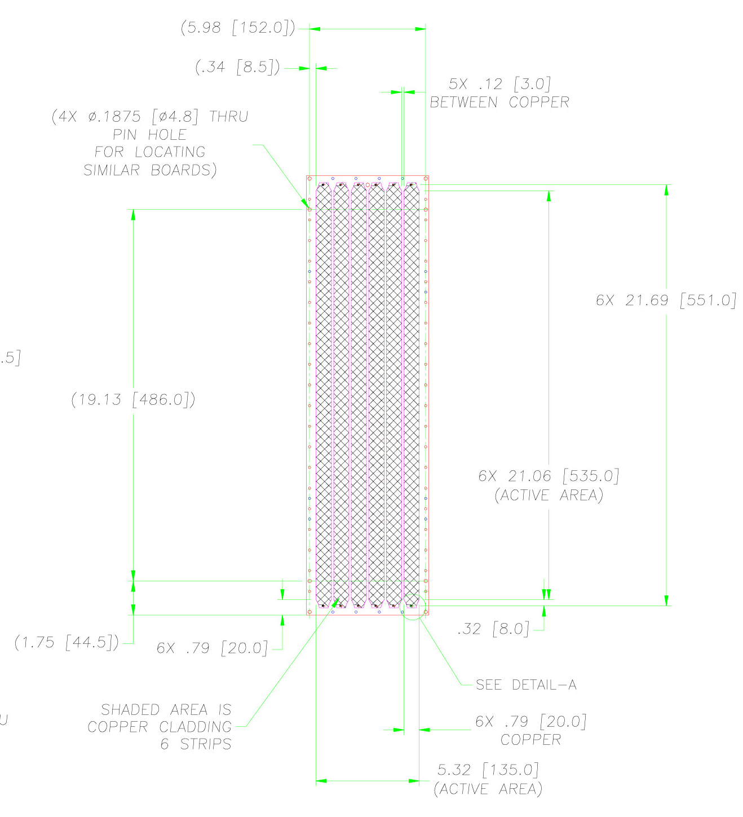

Figure 24. PH4 pick-up strips design. The drawing in the figure was used to produce the PCBs for this prototype.

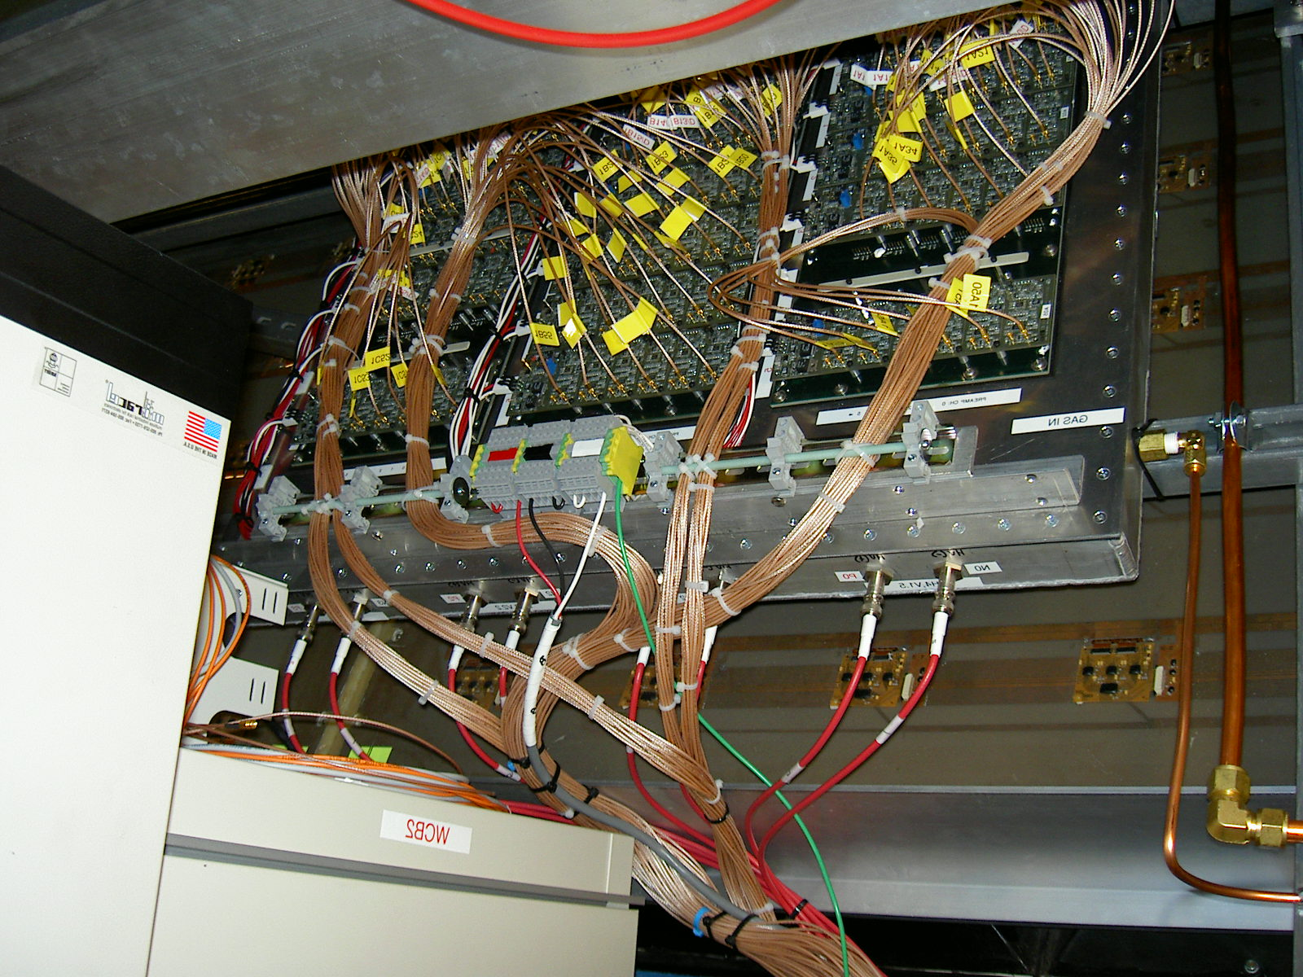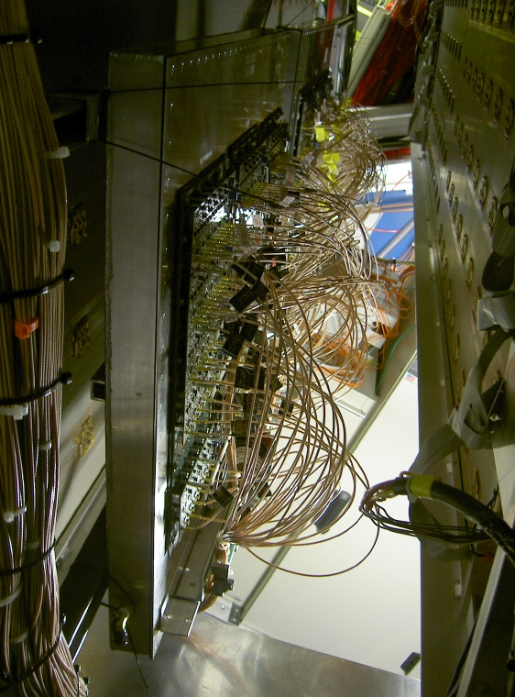
BOX1
BOX2
PC2

PH4 PH4 PH3 PH2

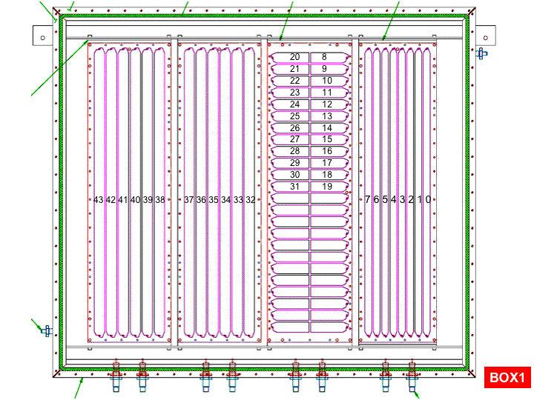

Figure 25. TOF West configuration in RUN5. Three different MRPC designs were operated in PHENIX during the Cu+Cu run. Two identical gas boxes were installed in sector W0 between PC2 and PC3 as shown in the photograph ( top figure).

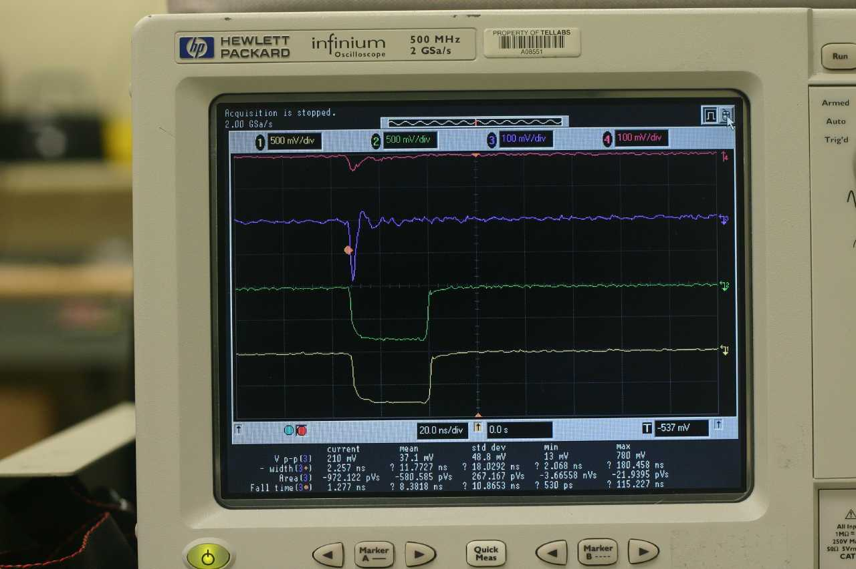

Figure 26. Pre-amp test with cosmic rays. Comparison between the RICE boards used in STAR during RUN3 and the boards used by PHENIX in RUN5.
Scope traces:
- CH 1 (yellow): bottom picture, discriminated signal from UNMODIFIED preamp ch. 500 mV/div.
- CH 2 (green): 2nd picture from bottom, discriminated signal from MODIFIED preamp ch. 500 mV/div.
- CH 3 (blue): 2nd picture from top, analog signal from MODIFIED preamp ch. 100 mV/div
- CH 4 (red): top picture, analog signal from UNMODIFIED preamp ch. 100 mV/div.

5.c RUN 5 results

The TOF.W prototypes were installed in November 2004 and operated for the entire duration of the Cu+Cu run (until March 31st, 2005). During this RUN, we also commissioned the low voltage system and the high-voltage system, which we expect to remain without modifications in the future runs. A description of these systems is provided in the Section 5 (Conceptual design).

The data collected during RUN5 is not yet fully analyzed. A mini-production was carried out in order to study the timing resolution, the efficiency and to compare digital and analog readouts. Most of the data was taken with 15 kV high-voltage setting, which was selected based on the results from the KEK beam test. A voltage scan was performed towards the end of the running period. Data was taken at 14 kV, 14.5 kV, 15 kV and 15.5 kV. All voltage scan data was taken within a 24 hour period.

5.c.1 Electronics and resolution studies
The goal of the electronics studies in Run5 was to compare the timing resolution obtained using the analog output of the pre-amp, which is then discriminated within the TOF FEM, versus the on-board discriminator. In both cases, the analog signal is recorded and is used to determine the slewing corrections. The concern is that the analog signal will deteriorate in the long cables between the pre-amp and the FEM. We used RG316/U cable, 50 ft long with LEMO plug on one end and MMCX plug on the other end. This is certainly not the best quality cable available and the length that is needed in the final configuration is significantly shorter, so this test should be considered as the worst case scenario for the final system. One of the early runs was used for this study. Here we present the results obtained using one of the PH4 chambers.
The timing resolution of the PH4 chambers was measured in a standard way by selecting high momentum particles and forming the difference between the measured flight time and the expected flight time under the assumption that the particle is a pion. Calibrations included slewing corrections and slat-by-slat timing offsets. Slewing corrections were done separately for the analog and the digital signals. The slewing effect is much more significant for the analog signals and requires a careful calibration. Figure 27 shows the Time-T_{expected} versus charge (ADC value) for one slat at the 15 kV HV setting. We found that the slewing curves depend on the applied high voltage and may also be affected by the percentage of streamers.

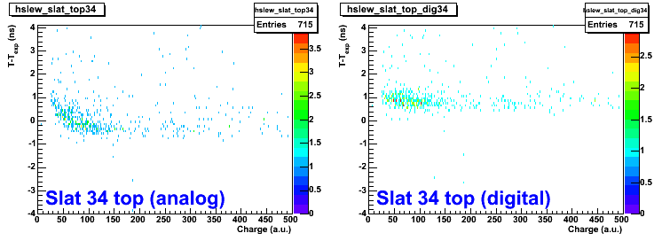

Figure 27. Time-Time_expected versus Charge (ADC value) measured with the analog (left) and the digital (right) read-out chain. The top read-out of slat 34 in PH4 chamber is shown. The voltage setting is 15 kV

Figure 28 and 29 show the momentum versus T-T_{exp} distributions obtained for the analog and the digital signals before and after slewing corrections. Significant improvement in the width of the timing distribution is achieved after this calibration.

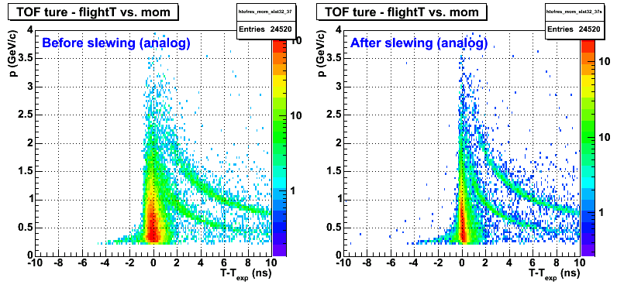

Figure 28. Momentum versus T-T_{exp} distributions obtained for the analog signals before and after slewing corrections. Negatively charged particles are included.

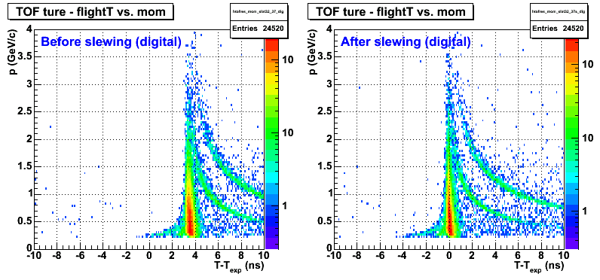
Figure 29. Momentum versus T-T_{exp} distributions obtained for the digital signals before and after slewing corrections. Negatively charged particles are included.

These plots show negatively charged particles only, since the acceptance in the W0 sector is worse for the positively charged particles. The distribution of 1/velocity versus charge*momentum for both charges is shown in Figure 30. A clear π/K separation is seen for momenta exceeding 2 GeV/c. The p/K separation is difficult to judge from this plot, due to low statistics, but we expect that it will reach above p_{T} = 4 GeV/c.

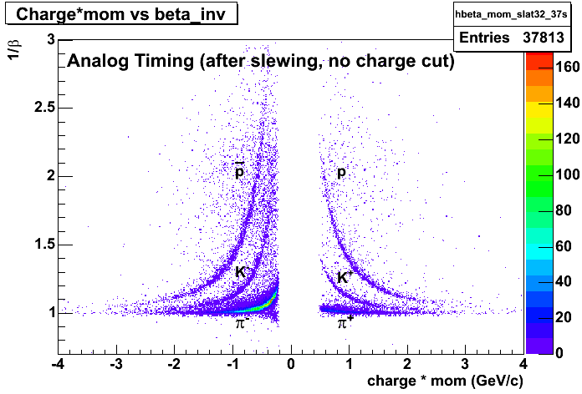
Figure 30. The distribution of 1/velocity versus charge*momentum obtained after slewing corrections (but no streamer cuts) with PH4 MRPC during the Cu+Cu run ( Run 5 @ 200 GeV).
The plots in Figure 31 show the timing distributions for the two electronics read-out chains. We obtain comparable resolution from the analog and digital read-out, which gives us confidence that the electronics solution (modified RICE pre-amp + TOF- East FEM) is suitable for the full detector construction. The resolution in Figure 31 of σ ~ 120 ps was achieved after applying slewing corrections, but has not been optimized by cutting out streamer contribution. It also includes contribution from the start-time counters (σ ~ 40ps). Figure 32 shows the effect of a charge cut that eliminates the tracks that result in streamers. The resolution is improved by ~20 ps. After subtracting the contribution from the start-time counters, we obtain intrinsic timing resolution of σ~ 96 ps, which satisfies our design goals.

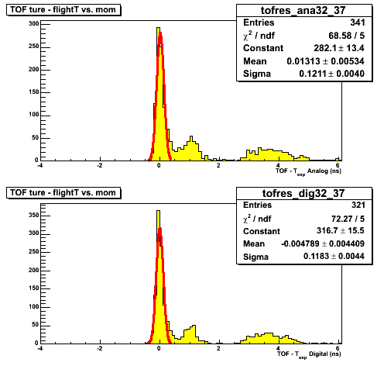

Figure 31:
- Timing resolution: with NO streamer cuts applied and no start time subtracted
- Analog: 121 ps (top plot)
- Digital: 118 ps (bottom plot)
- Comparable timing resolution between analog and digital signal.

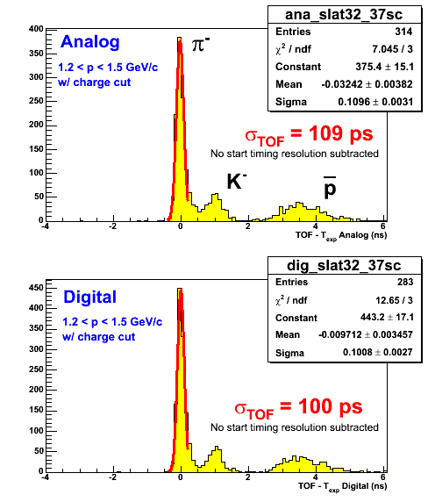

Figure 32. Timing resolution in the PH4 chambers after streamer cuts were applied. Analog and digital signals are compared. The contribution of the start time counter ( σ ~ 40 ps) has not been subtracted.

The resolution was also studied as a function of position within the MRPC. The slat-by-slat results for one of the PH4 chambers are shown in Figure 33. The timing resolution for analog and digital signals is shown. The solid points
Show the results without streamer cuts. The open points show the results after the streamer cuts are applied. In both cases, the start time resolution is not subtracted.

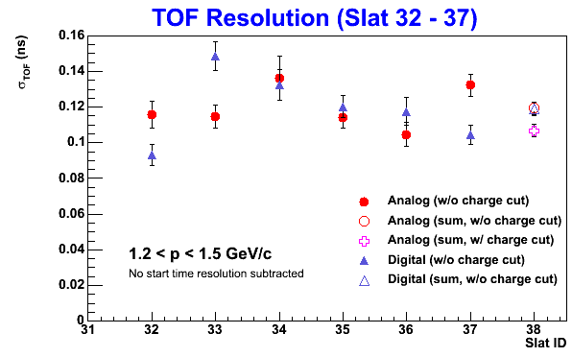
Figure 33 Slat-by-slat timing resolution in the PH4 chambers at 15 kV.

5.c.2 Efficiency studies
One of the goals for RUN 5 was to compare the efficiency of the narrow strip design ( PH2) with a wider strip design (PH4) MRPC. Since the efficiency depends on the applied high voltage, we conducted this study using the high-voltage scan data. The efficiency of the MRPC was determined under the following conditions:
- Good quality tracks are selected from the drift chamber
- Tracks are matched with hits in PC2 and PC3 that are located in front and back of the MRPC, respectively. Cuts in PC3 -z are used to define the MRPC chamber which is expected to register the hit.
- The efficiency is determined as the number of hits in the MRPC associated with the tracks that pass the above selection divided by the total number of selected tracks.
The results for the efficiency obtained using two PH2 chambers and two PH4 chambers as a function of the applied high voltage are shown in Figure 34.

Figure 34. Efficiency study comparing PH2 and PH4 chambers in gas box 1 and gas box 2.

The blue point in the figure show the efficiency in the PH2 design, while the red points show the results for the PH4 chambers. The two sets of points (open crosses and filled triangles) correspond to the two different gas boxes. The PH4 chambers show efficiency in the range 92- 97% for voltage settings between 14 kV and 15.5 kV. The results obtained from the two gas boxes are consistent. The PH4 efficiency is systematically higher than the PH2 efficiency, although the difference is close to the level of the systematic error of these studies. In any case, we have confirmed that the wider strips perform at least as good as the PH2 design that was tested in KEK and possibly – about 2% better. We note that the 98 – 99% efficiency numbers quoted by STAR and ALICE were only achieved when using a 3 component gas mixture.

5.c.3 Operating conditions studies with heavy ion beams

For the most part of RUN5 the MRPCs were operated at 15 kV, which was determined to be optimal voltage setting in the KEK test. Voltage scan data at four settings was also taken towards the end of the Cu+Cu run. We studied the timing resolution, the efficiency and the streamer component as a function of high voltage. The data analysis is still ongoing. Here we present the first results from this study.

First we note that the slewing corrections apparently are voltage dependent, which is probably due to the gain change with HV. The second observation is that the timing resolution results obtained in the voltage scan data are worse by ~ 10 -15 ps compared to the results during the Run. This could be due to the fact that the MRPCs need longer conditioning after a voltage change, which was not done during this voltage scan. We also find a larger percentage of streamers during the voltage scan (for the same voltage setting of 15 kV). Figure 35 summarizes the timing resolution results from the voltage scan. The resolution was measured with and without the streamer contribution. We find that the resolution in the avalanche mode does not change within these voltage settings. The nominal operating voltage can be lowered from 15 kV to 14 kV. This will result in a better performance with a much smaller percentage of streamers.

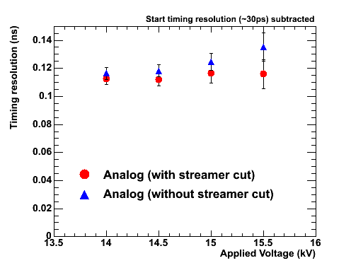
Figure 35. Timing resolution for PH4 as a function of applied HV.

The streamer contribution was measured during the HV scan and for the earlier Runs. Figure 36 summarizes the results. Unlike in the KEK beam test, the performance at HV > 14.5 kV with heavy ion beam has unacceptably high percentage of streamers. While the good timing resolution can be retained by cutting out the streamers, operation under these conditions is not desirable. One solution would be to lower the operating voltage. Another approach (used at CERN and elsewhere) is to add a small percent of SF₆ to the gas mixture. HV conditioning is also needed. We note that the 15 kV data in the voltage scan was taken just after the 15.5 kV data and the streamer contribution was increased significantly compared to earlier runs at the same voltage setting.

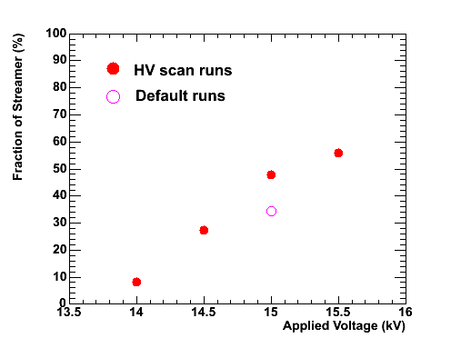
Figure 36, Streamer percentage measured in the HV scan during the Cu+Cu run.

To investigate the dependence on the environment and to test if the MRPC can recover after operation with very high streamer rate (such as at 15.5 kV), we evaluated the streamer component of the same chamber using cosmic rays at Vanderbilt after the detector was decommissioned. The ADC distribution at 15 kV is shown in Figure 37. The streamer component is reduced by a large factor in comparison both to the default runs and the voltage scan runs. We conclude that in the high multiplicity/high rate environment, the streamer contribution is increased and needs to be closely monitored.

Figure 37. Streamer contribution measured with cosmic rays at 15 kV. The measurement was done after decommissioning the detector. No apparent damage was found.

as a continuation of our R&D studies. After the KEK test, the designs that remain under consideration are PH2 and PH3. We would also like to build strip chambers with wider strips (PH4) in order to improve the efficiency in the strip design. This evaluation is crucial for the successful construction of the full system for Run6. To achieve this goal we are planning to install 2 gas boxes, each approximately 55x55 cm² in sector W0. Box 1 will contain the new design PH4 chambers. In box 2 we will install 2 chambers of each PH2 and PH3. We will also test the performance of the full electronics chain. We hope to obtain valuable information starting from the beginning of Run5, such that the decisions can be made and the detectors can be built for Run6.

6. Conceptual design of the full TOF West system
The following conceptual design is based on our R&D studies tested at KEK and in Cu+Cu beams at RHIC ( RUN5)

6.1 MRPC design
The TOF West system will be constructed with single stack, 6 gap MRPCs. In order to optimize the coverage, the size of the chambers slightly different from the PH4 design, but the read-out strips will have the same active area ( and occupancy) as the PH4 chamber. In the final design, the MRPCs will have 4 strips with double ended readout. The thickness of the glass and the gas gaps will remain the same as for the prototype detectors. Figure 38 shows a cross sectional view of the final chambers with all components and sizes included.
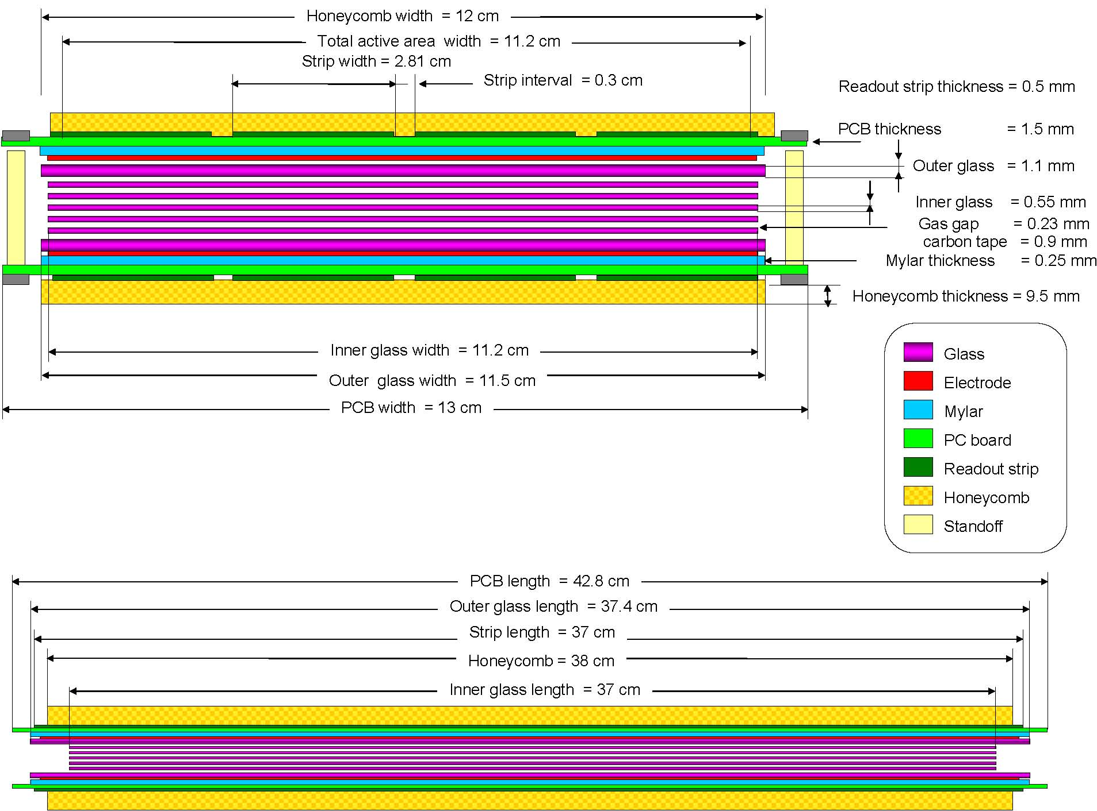

Figure 38 . Cross sectional view of the TOF.W MRPC to be installed in sector W1. All components and sizes are labeled in the figure. The two views are not to scale.

Figure 39. PCB drawing for the TOF.W MRPC showing the

Table 1 shows the channel count for the full system.
count | MRPC | panel | sector | Note
MRPC chambers | 1 | 32 | 128
Strips | 4 | 128 | 512
Readout ch | 8 (top and bottom readout) | 256 | 1024
HV+ | 1/8 | 4 | 16 | 4 A631P ( 4 ch each), located 2 South + 2 North
HV- | 1/8 | 4 | 16 | 4 A631N ( 4 ch each), located 2 South + 2 North

Table 1. Channel count in each of 3 possible TOF West configurations. The FEM channel count assumes that in the case we will build PH3 chambers, multiplexing by 3 will be possible at the input to the FEMs.

7. Budget
Table 2 below details the cost of pre-amp electronics, FEMs, MRPC construction and HV system. There will be additional cost for LV, gas system and infrastructure to get the TOF West system on carriage. We expect that this cost will be covered by BNL and it is not included in this estimate. The table contains cost estimates for the 3 different designs outlined above. Although the number of channels is very different, the pre-amp cost is similar, because the price/channel changes significantly with the number of channels. Similar change in price may occur for the FEMs, but here we assumed that in the case of PH3 construction (~3072 channels) we will find a way to multiplex by 3 before the input to the FEM, so the FEM price for PH2 and PH3 is the same.
electronics:
 | per channel ($) | 1 sector PH2 (in k $) | 1 sector PH3 (in k $) | 1 sector PH4 (in k $) | project total (in k$)
pre-amp (ch. count ~ 500) | 60 |  |  | 34.56
pre-amp (ch. count ~ 1000) | 50 | 51.2
pre-amp (ch. count ~ 3000) | 26 |  | 79.872
pre-amp revision (to fit our space) |  |  |  |  | 20
pre-amp contingency 25% |  | 12.8 | 19.968 | 8.64
PCB revision for multiplexing |  |  | 20
total pre-amp |  | 84 | 139.84 | 63.2
FEM | 100 | 102.4 | 102.4 | 57.6
FEM 25% contingency |  | 25.6 | 25.6 | 14.4
total FEM |  | 128 | 128 | 72
detector:
 | per gas box ($)
glass | 250
honeycomb | 120
PCBs (8 per box) | 1200
box (materials + machining + connectors) | 800
cables (signal,HV, LV) | 3350
glue | 20
standoffs,screws,fishingline | 50
HV wire inside box | 50
carbon tape elctrodes | 10
mylar film | 10
total MRPC cost per gas box | 5860
add contingency MRPC (only) 50% | 7115
add VU overhead on materials (51%) | 11460.9
total MRPC for full sector (in k$) | 183.3744
High Voltage | per unit (in k$) | total for sector
mainframe | 13 | 26
controller | 2.1 | 4.2
HV cost/channel | 0.8 | 25.6
spares (1 mainframe+4 modules+1 controller) |  | 27.9
total HV cost (in k$) |  | 83.7
 |  | PH2 design | PH3 design | PH4 design
total detector + HV+electronics cost (in k $) |  | 479.074 | 534.914 | 402.274
total funds needed at Vanderbilt |  | 351.074 | 406.914 | 330.274

Table 2. Budget estimate.

The MRPC technology is cost efficient. As indicated in the table above, the detector itself is less than 1/3 of the whole cost. This allows large area coverage to be achieved with the fraction of the cost for conventional technology (scintillator + phototubes).

8. Facilities and resources
The construction of the MRPCs and the gas boxes will take place at Vanderbilt University. The Relativistic Heavy Ion Group has lab space available for such projects. In addition, the group has a class 1000 clean room equipped with optical tables that provide extremely flat surface for chamber building. This facility, priced at $300k, was used for the construction of the PHENIX pad chambers which have proven their superb quality over the first 3 years of RHIC. Vanderbilt also has a good quality machine shop and a group of skilled technicians available which are crucial to such an effort. Electronics shop is not available onsite, but there are several possible options. The FEMs will be built at Nevis. We are currently discussing with Rice engineers the possible options for the pre-amps. The revision of the boards will be done at Rice. The production will be contracted with a company. The pre-amp testing needs to be done by PHENIX. The work will most likely be split between Vanderbilt and Tsukuba. The Tsukuba group has also expressed interest in contributing to the MRPC R&D effort.
We have used and will continue to use engineering support from BNL for the design of the gas boxes, the drawings of the PCBs and the integration on carriage. BNL group has also agreed to take responsibility of the gas system in the IR.
Significant funds from Prof. Velkovska’s start-up funds from Vanderbilt have already been devoted to the TOF West project. This includes lab equipment, the cost of prototypes, cosmic ray test station, gas system at VU, travel to BNL and Japan (for beam test). In addition, Prof. Velkovska’s OJI award from DOE is to be spent 100% on the TOF West project. The OJI grant will cover ½ post-doc salary, a CAEN HV system for the Vanderbilt test stand (not included in Table 2 above), lab supplies and materials for sustaining a large production and testing effort.
The manpower resources at Vanderbilt are currently limited, but we expect to be able to improve this situation by involving more undergraduate students in the construction effort. Currently we have 1 post-doc, 2 graduate students and 2 undergraduate students working on this project. We expect to be able to recruit another graduate student in the coming year.

9. Schedule
The full system has to be on carriage for Run6. Currently we have a good estimate of the FEM, pre-amp and HV channels. The electronics and HV modules have a long lead time. It will take 9 months to build and test the FEMs, 6 months to complete the pre-amp production and testing, 3 months to get the CAEN HV modules produced. If we can proceed with the orders for these components in August/Sept 2004 , then we will have them ready at a reasonable time to be able to go on carriage for Run6. The MRPC components are mostly off-the-shelf. We estimate 2 months to collect all components. Most of the components can be ordered even before the final design decision has been made, since we will only vary the PCB design, but not any of the other parameters. Having in mind that the success rate of the MRPCs is ~ 75%, we need to build and test ~ 100 chambers to complete the project. It is possible to build a chamber in 2-3 days, but since none of our students is available to work on this project full time, we estimate that 1 week will be needed to complete a building procedure. We can build 5 chambers simultaneously. Then the whole project can be done in 5 months. We will instrument a cosmic ray station in which 5 chambers will be stacked and taking cosmic ray data simultaneously. In that way, each chamber will collect cosmic rays for 1 week, during which time the next production batch will be finished and prepared for testing. The gas box construction can proceed in parallel with the chamber building. If we want to be done with the construction in July 2005, we need to start building in February. This then means that the MRPC components have to be ordered by the end of 2004. We will analyze the data from the prototypes installed in Run5 as soon as beam is available. We expect that we would need a couple of weeks data to make our final design decision. The schedule presented here is very aggressive, but is possible to accomplish, if no major unanticipated problems occur.

10. Acknowledgement
We acknowledge the invaluable help of the STAR TOF collaboration and particularly the help of Bill Llope. Bill taught us how to build the detectors, lent us pre-amp electronics, helps us with designing pre-amp boards that will interface to the PHENIX front-end modules and in the past 7 months has answered numerous lengthy questions from all of us at Vanderbilt.
We also acknowledge the help of the Tsukuba group during the beam test at KEK. The problem solving skills and the hard work of the students was impressive. Prof. Esumi spent his days on the floor with us and Prof. Miake took care of every logistic detail. We thank them for the warm hospitality. Our test could not have succeeded without them.

11. Bibliography

[1] PHENIX Collaboration, K.Adcox et al., Phys. Rev. Lett. 88,022301,(2002).
[2] PHENIX Collaboration, K.Adcox et al.,Phys. Lett. B,561,19757(2003).
STAR Collaboration, C.Adler et al., Phys. Rev. Lett. ,89,202301,(2002).
[3] PHENIX Collaboration, S.S. Adler et al.,Phys. Rev. Lett.,91, 072301 (2003)
[4] STAR Collaboration, C.Adler et al., Phys. Rev. Lett.,90,082302,(2003).
[5] STAR Collaboration, J.Adams et al.,submitted to Phys. Rev. Letters ,arXiv:nucl-ex/0306007.
[6] X.N.Wang and M.Gyulassy, Phys. Rev. Lett. 68, 1480, (1992); X.N.
Wang, Phys Rev C58, 2321 (1998);
R.Baier et al., Phys. Lett. B345, 277 (1995).
[7] PHENIX Collaboration, S. S. Adler et al.,
Phys. Rev. Lett., 91, 072303 (2003) [arXiv:nucl-ex/0306021].
[8] STAR Collaboration, J.~Adams et al. , Phys. Rev. Lett., 91, 072304 (2003)
[9] PHOBOS Collaboration, B. B. Back et al. ,Phys. Rev. Lett. 91, 072302 (2003)
[10] BRAHMS Collaboration, I.~Arsene et al. ,Phys. Rev. Lett.,91, 072305 (2003)
[11] D. Kharzeev, E. Levin, L. McLerran, Phys. Lett. B 561,93,(2003).
[12] PHENIX Collaboration, S. S. Adler et al.,Phys. Rev. Lett.,91,172301,(2003)
[arXiv:nucl-ex/0305036].
[13] PHENIX Collaboration, S. S. Adler et al.,Phys. Rev. Lett., 91,182501,(2003)
[arXiv:nucl-ex/0305013].
[14] E.V.Shuryak,
Phys. Rev. C 66, 027902 (2002).[arXiv:nucl-th/0112042].
[15] D.Molnar and S.A.Voloshin, arXiv:nucl-th/0302014.
[16] STAR Collaboration, J. Adams et al., submitted to Phys. Rev. Lett. Sept. 16, 2003. [nucl-ex/0309012]
[17] Proposal for a Large Area Time of Flight System for STAR, http://wjllope.rice.edu/~TOF/
[18] CERN/LHCC 2002-016 Addendum to ALICE TDR 8, 24 April 2002

LV
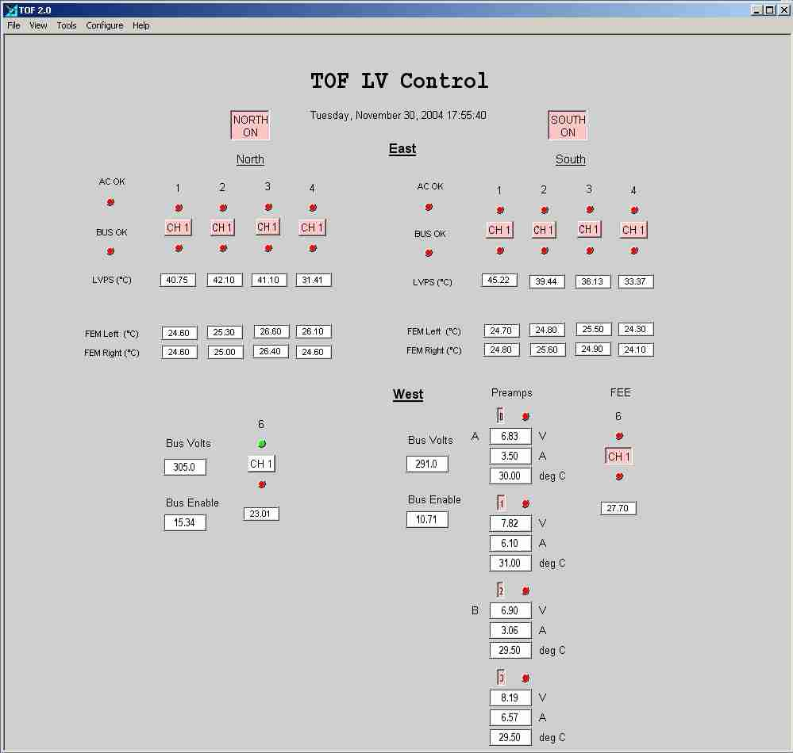

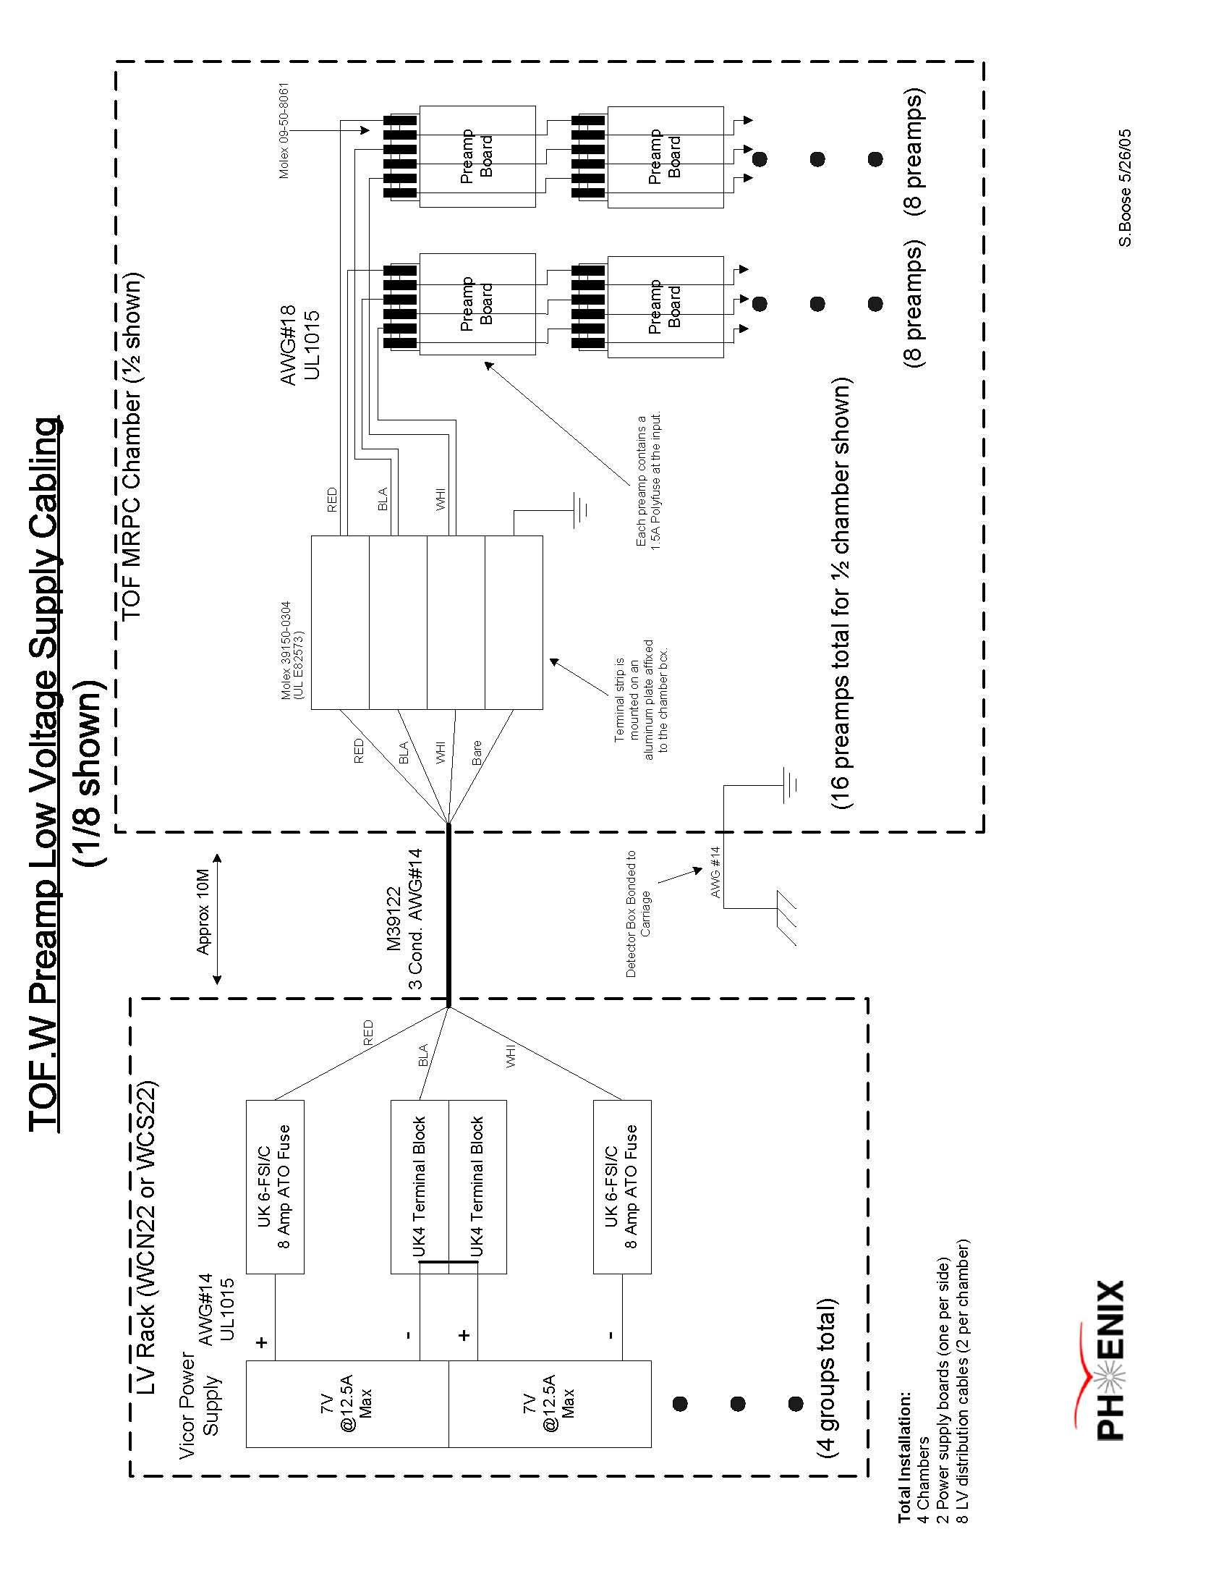

High voltage
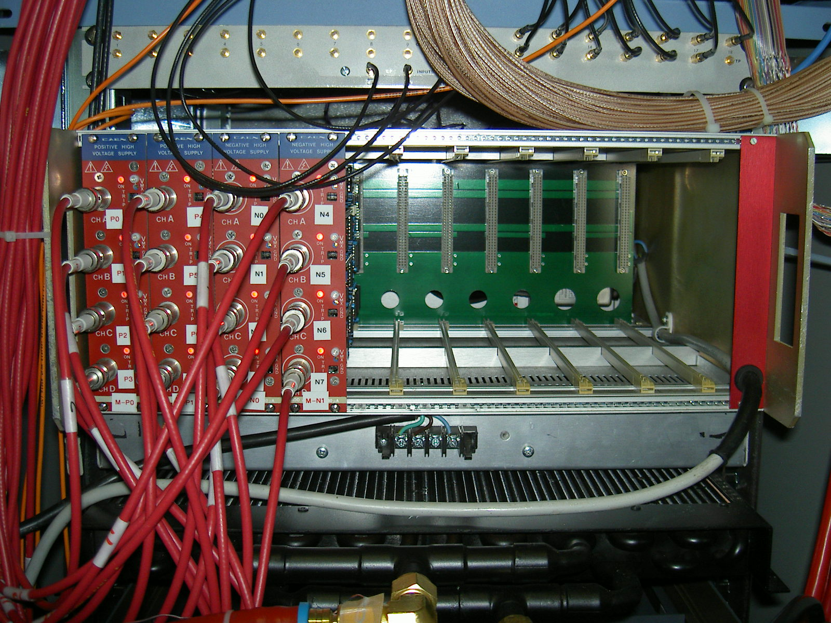
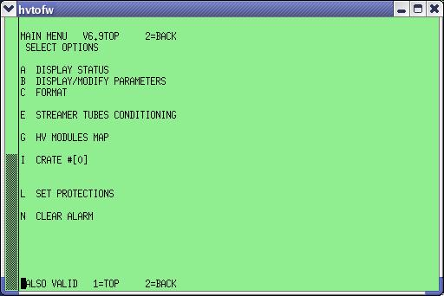

Electronics
Revisions to the STAR designs of these two boards
were made for the PHENIX Run-5 implementation.
These include the removal of a back-termination
resistor, as well as modifications to the feedback
to the amplifier to improve the rise-time of the
analog signal. This was to make the performance
of the analog outputs, as digitized in the
PHENIX style so-called "FEMs". Rice constructed
40 FEE boards with these modification and their
performance with the PHENIX MRPCs in Run-5 appears
to be to specification (~105ps total resn obtained).

- "Garage Door" installation requires both F/T & FEE boards,
but w/ very different physical layout as compared to the Run-5
versions. board footprint of order 3"x12". footprint &
mounting hole pattern still TBD by phenix... also TBD
is size of "big holes" in the cover assy (to allow
MRPC cables to connect to underside of F/T boards) and
hence the component fiducial on the F/T boards...
since both the F/T & FEE boards are "small", both can
both be .063" thick.
- no LV needed on F/T board
- remove both the logic section and the test input feature
on FEE boards. should drop power draw by roughly
a factor of two (cost and fab time also positively
impacted).
- MRPC PCBS need not have same trace lengths
for all pads. another thing to think about is that
your MRPC signal traces are straight lines w/
sharp right-angle edges. from a fourier perspective
wouldn't that hammer the highest frequencies (which
contribute importantly to your signals' rise time)?
our traces are wider, and more rounded/curvy... see
attached pdf (pad68.pdf)...
- open issue: surface mount pins vs through-hole pins on F/T
boards?
- change single large ribbon cable header on MRPCs into
two 8pair ribbon headers. allows either single or double
pairs per pad, plus empty ground pairs in between to
reduce any possible cross-talk.
- rice will check into possible replacements for AD8001 amps
on the FEE boards (in case large gain*bandwidth is now available).
-> AD8000. ted guesses roughly factor ~2 improvement
in gain*bandwidth. you can test this julia by replacing
the AD8001 with the AD8000 on one of your Run-5 boards.
you will also need to play with different values for two
resistors - ted can specify which ones these are on
the schematic....
- need to bench test doubling up of signal pigtails.
dbl'ing the twisted pairs lowers the impedance (generally
a good thing). but for the much larger pads you have (larger
capacitance), dbl'ing up the signal pairs per pad may
put yourself near the limits of the maxim 3760's capabilities.
-> bench test this idea w/ run-4 electronics & cosmics...
- i'm still nervous about an MRPC mechanical mounting scheme
that squeezes or flexes the MRPC stack. we use "slots"
that are ~20mils larger than each of the 3 MRPC dimensions, so
that the mrpcs aren't squeezed at all but rather are just sitting
on 'a shelf' due to gravity alone. maybe you need more support
but still it might be possible to do this w/out squeezing
the mrpc stacks
- mechanical design of MRPC gas box is quite exotic, and
requires hydroforming or deep-drawing aluminum. limited # of
fab shops w/ these capabilities.
well-depth presently ~1.06" which is comfortable:
20mils(max sealant)+063(pcb)+437(standoff)+063(pcb)
+350(components/connectors above FEE) = 933mils, leaving
~120mils in reserve. probably safest to keep this
reserve in the design of the well-depth for now...
- suggest cable path off FEE is: Right-angle MMCX through-hole
mounted jacks -> mmcx plugs on RG-316 to phenix patch panel.
RG-316 cable run in run-6 to be about a factor of 4 shorter
than in run-5.
- F/T boards cannot simply be glued/sealed to cover assy - this
would not tie the ground planes in the F/T board to the ground
of the cover - breaking the faraday cage about the MRPCs.
need to use some mechanical mounting to carry the cover ground
to the F/T & fee grounds at many locations around the circumference
of these boards. we use PEM studs spaced every 1-1.5".
- use board mount screw-posts, plus simple crimp lugs on cable,
to run LV from board to board.
- MRPC HV connections to HV feedthrough on gas box need
not be strictly parallel. serial, or some combination of
serial and parallel, are fine too. the current
draws here are measured in nA - so the voltage drops
inside the gas box are negligible really.
solder HV pigtails to sections of rowe cable, in groups
of a few if necessary, then wrap each junction w/
several layers of silicon fusion tape (e.g. Rowe GL30R67WO,
tyco also makes a version according to www.newark.com,
but check the dielectric strength on that one - i didn't).
- tentative schedule limits: (assumes Nov 1 cooldown, and
STAR at least is pushing for a delay of this until ~Dec 15,
so detector commissioning need not occur during the holidays,
but for now let's say Nov 1 cooldown):
Sept 1 - F/T boards done & shipped
Oct 15 - FEE boards done & shipped

BROOKHAVEN NATIONAL LABORATORY

Phenix Time of Flight Cambers Gas System

Original Proposal by
Leonid Kotchenda
03/20/02

Modified and Update for Phenix by
Robert Pisani
05/23/2005

Abstract

The Phenix TOF Gas System supplies 95%R134a+5%i-Butane mixture to the Time of Flight West (TOF.W) chambers at a controlled pressure. This system can regulate the flow rate of mixture while monitoring mixture temperature, flammable gas content, Oxygen and Moisture. A computer control/data acquisition system collects and logs the gas system operating parameters while providing a means of remotely controlling system valves.

Contents

Introduction
Pressure Control
Temperature Measurement
Mixture Control
Gas Sampling
Gas Purification
Computer Control and Data Acquisition
List of Fault Conditions

Introduction

The primary purpose of the TOF Gas System (Fig.1) is to provide 90%R134a +5%i-Butane mixture to the TOF chambers at the correct constant pressure. Refer to Table 1 for a list of gas system parameters.

Fig.1 PHENIX TOF chambers Gas System

The system operates nominally as a closed circuit gas system with the majority of the gas mixture recirculating through the TOF chambers and delivery system. During normal operation, a small amount of fresh mixture is added and equivalent quantity of the return mixture is vented. The gas system can also be operated in a single pass open system configuration for purging.
The mixture circulation rate through the small membrane compressor is about 10 LPM at 60” H20 pressure. The gas system uses two compressors (C1, C2), one active and one set up as a backup. The gas from the compressors returns to the supply line through the check valves CV8 or CV9 depending on which compressor is active. The 60” H20 output pressure from the compressor is reduced to 30” H20 pressure by a pressure regulator (PCV1) before returning to the chambers. The compressors output pressure level is maintained with the back pressure regulator (BPCV1).
The return gas manifold is maintained at 1” H20 pressure above atmospheric pressure by a differential pressure transmitter (PT3) and electro-pneumatic PID Controller (PIDC) that operates bypass valve (PBV1). The bypass shunts flow from the compressor discharge line directly back to the compressor’s inlet. A second manual bypass valve (MV1) is adjusted to enable the automatic control loop to be used within its optimum range.
The bypass line which includes the back pressure control valve (BPCV2) gives the possibility for a smooth gas system start. It also provides means for a rapid response to increased or reduced i-Butane content measured with the i-Butane analyzer upstream of compressor.
Two flow indicators (FI6 and FI16) will measure the recirculating flows: main and bypass. A difference between of them is the flow through the TOF chambers.
A measurements of the fresh mixture (FM1, FM2) into the system and flow vented through the flow indicator FI15 will give an estimate of the systems leak rate.
The purity and composition of the mixture is monitored using oxygen, i-Butane and humidity analyzers. A fraction to all of the recirculating mixture can be passed through a purifier and dryer to remove moisture and oxygen contaminants as needed.
A computer driven data acquisition/control system monitors all of the process variables. The computer system flags quantities which fall outside of predefined limits and initiates corrective action. The computer system also transmits an alarm to the Phenix crew to alert them of any problems.
It is imperative, for the safety of the devices, that the TOF chambers inside pressure accurately tracks barometric pressure. A rapid change in atmospheric pressure is typical preceding storms and hurricanes. To assure that the TOF chambers follow a fast rise in atmospheric pressure, a relatively large flow of inert gas will admitted into the TOF chambers in the event that normal pressure controls fail to keep up with “falling” internal pressure. The vent lines and associated valves are sized to allow for rapid venting of the TOF chambers mixture to prevent a high internal pressure in the case of the fast barometric pressure drops.

Table 1. Performance of Gas System is as follows:

Mixture (90%R134a+5%i-Butane)
Compressor pressure 40-60 “ H2O
Supply pressure 30”+/-0.05 H20
Return pressure 1” +/-0.05 H2O
Recirculation flow 650-1000 ccm
Mixture flow through
TOF chambers 850 ccm
Purge flow 3.5 l/m
Make-up mixture flow 100-300 ccm
Oxygen content < 500ppm
Water content <100ppm

Pressure Control

There are two sources of pressure in the system: the first is the compressors located at the return from the TOF.W chambers. The second is the flow of fresh gas through the mixing manifold at the input of the system. Nominally the pressure within the TOF.W chambers is controlled by maintaining a constant pressure upstream of the TOF.W via the pressure reducing regulator (PCV1) plus back pressure regulator (BPCV2) and varying the pressure downstream of the TOF.W chambers by regulating the amount of mixture shunted from the compressor output to inlet (measures at PT3). On a longer time scale the flow of fresh mixture is constant.
The output from the compressor is 650 to 000 ccm at 60” H20 pressure. A back pressure regulator (BPCV1) in the outlet line is set to 60” H20 pressure thus maintaining a maximum delivery pressure independent of the compressor’s output. This pressure is reduced to 30” H20 pressure by the pressure regulator (PCV1) and supported with the back pressure regulator (BPCV2) upstream of the TOF.W chambers. The TOF.W chambers exhaust pressure, measured at the return gas manifold is maintained at 1” H2O pressure by a TESCOM ER3000 electro-pneumatic PID controller. A 0-2” H2O differential pressure transmitter (PT3) on the return manifold produces a 4-20 mA output that the PID controller compares to a set-point value. If the transmitter signal is different from the set-point, the controller sends a pneumatic output signal to the bypass control valve (PBV1). The bypass shunts flow from the compressor discharge line directly back to the compressor’s inlet. Opening the bypass valve causes the TOF chambers exhaust pressure to rise and closing the valve makes the pressure fall. A second bypass valve (MV1), manually adjusted during the initial system set-up, enables this automatic control loop to be used within its optimum range.
The fresh mixture is admitted between the pressure regulator (PVC1) and back
pressure regulator (BPCV1). The quantity of fresh mixture can be adjusted in the range of 100-3000 ccm with the mass flow controllers (FM1, FM2). To purge the detectors with a quantity up to 3.5 l/m inert gas, the flow indicator (FI1) is used. Simultaneously, gas is removed from the system through the back pressure regulator (BPCV1). To have the stable content of fresh mixture, the R134a mass flow controller (FM1) operates the i-Butane one (FM2). This means that FM1 flow controller is the master controller and FM2 flow controller is the slaves. These units are normally locally controlled. I-Butane flow is turned off if the R134a mixture is interrupted. The quantity of fresh mixture is monitored with PC data acquisition/control system.
When the internal TOF chambers pressure, as measured by PIT4-PIT7 is more then 1.5” H20 above the atmospheric one, the gas control system will close the solenoid valves (SV2,SV3) in the fresh mixture supply line and open the vent line valve (SV9) allowing the mixture to vent directly to the atmosphere.. Also, the pressure indicating switch (PIS1) has a set-point of 1.50” H20 pressure and it can operate SV2, SV3, and SV9 through hardwired controls. Should the TOF cambers internal pressure reach 2” H20, the out going TOF chambers mixture will vent to the atmosphere through the safety bubbler. With this arrangement, the TOF chambers are protected from either flow controller malfunction, a rapid drop in atmospheric pressure and/or a failure of the back pressure regulator.
In the event of a rapid rise in atmospheric pressure, or effectively a fast drop in the TOF.W chambers internal pressure (up to 2.5” H2O/min), dual set point differential pressure transmitters (PIT4-PIT7) in the return manifold will trip as the pressure falls below 0.2” H2O causing an audible and visual alarm. When the pressure at PIT8 falls below atmospheric (0.05” H20 gage) a second set-point trips and the computer control system will stop compressor, shut off the flow of i-Butane, and flow inert gas by opening solenoid valve (SV1) to supply an additional 3.5 l/min of inert gas.
A pressure indicating switch (PIS1) with dual set points is installed in the return manifold. This switch is not connected to the computer control system but instead is hardwired to perform the same functions as computer in the event of a falling TOF.W chambers pressure. Thus the system is equipped with two separate means of preventing the TOF.W chambers from experiencing an external over or under pressure.
In the event of a power failure, the solenoid valves SV1, SV2 and SV9 will open, or remain open and SV3 will close, causing 3.5 l/min of inert gas to flow through the TOF chambers. This flow rate is adequate to assure that fluctuations in the atmospheric pressure will not result in the creation of over or negative pressure inside the TOF chambers.
The computer data acquisition /control system will measure the atmospheric pressure with a barometer (BP) to have the absolute pressure data.

Temperature Measurement

Two temperature transmitters (TT1, TT2) are used to measure the mixture temperature within the TOF chambers. The data of measured mixture temperature are logged for later use in data reduction.

Mixture Control

Along with automated valve control, the gas system’s dedicated computer controlled data acquisition provides constant monitoring of the mixture composition by measuring the mass controllers output signals. I-Butane analyzer will be used periodically to check i-Butane content in the mixture. The mixture ratio is fixed by the Teledyne mass flow controllers (FM1, FM2) with the flammable gas “slaved” to R134a flow controllers. The stability of the flow controllers is sufficient to make variation in the mixture negligible.

Gas Sampling

The gas system is equipped with Oxygen, Moisture and i-Butane analyzers plumbed such that each section of the gas system can be selected separately for evaluation (through SV5, SV6, and SV7). All analyzer’s data are read and archived by the computer data acquisition system and used to control the gas system.

Gas Purification

A gas dryer and purifier withdraws a portion (up to full amount) of the reciculating flow upstream of the pressure regulator (PCV1) and delivers the conditioned gas to the recirculating flow upstream of PCV1. This loop is used only as needed. The dryer is made from a stainless steel tube containing 1 lbs of molecular sieve (zeolite 13X) as the adsorbent. This amount permits the removal of about 0.4 lbs of water vapor to a level 2-3 ppm at room temperature. Filters are installed upstream and downstream of the adsorbent to prevent particles from entering to the mixture stream. A heating element is installed around the dryer which is then wrapped with fiber glass thermal insulation. The dryer is regenerated by heating it to 350-400C while purging with a mixture of Argon +5%H2. The purge gas enters at the top of the dryer and exits at the bottom carrying with it the water vapor. A temperature transmitter installed inside the dryer is connected to the temperature controller (TIC2) that supports the dryer temperature on the set-pointed level during regeneration. A moisture analyzer is used to measure the quantity of the water in the circuit before and after the dryer to determine when the adsorbent is saturated.
The purifier is similar to the dryer except that it is filled with a pure copper. The oxidization process takes place at 220 C that is supported with the temperature controller (TIC1). A heat exchanger (HE1) is used to reduce the mixture temperature coming into the dryer. This purifier is regenerated with the same purging gas as the dryer. Solenoid valve (SV8) installed at the inlet of the purification loop isolates the unit from the main circuit when it is not in use. If the inside pressure of purifier/dryer exceeds 1/3 PSI, the check valve (CV7) works as the safety valve and prevents the purifier/dryer from being damaged.
A 10 micron filter is installed after the purifier/dryer to prevent dust from passing into the main mixture supply line. A differential pressure transmitter (PT4) is used to determine when the filter needs to be replaced.

Computer Control and Data Acquisition

The gas system includes a computer driven data acquisition and control system. The controlling computer is a dedicated PC with Intel Pentium processor. It reads the data and operates the gas system through a National Instruments SCXI system. This computerized system is programmed to acquire the signals from the various temperature, pressure, flow and content measuring devices. It will issue warnings and/or take corrective action in the event that predetermined levels are exceeded. All acquired values can be selected and viewed on the terminal. The gas system can be monitored remotely through the internet though a secure host as well. The gas system alarms are sent to the Phenix Safety System and alerts the shift crews of any problems.

List of Fault Conditions

Fault Level Action

1. PT-6 <0.05” H2O Stop Compressor, gas purge(open SV1)
Alarm(audible, flashing light)
2. PT-6 <0.2” H2O Alarm(audible, flashing light)
3. PT-6 >1.50” H20 Alarm(audible, flashing light)
Close SV2, SV3 ; Open SV9
Alarm(audible, flashing light)
4. PT-1 <6PSI Alarm(audible, flashing light)
5. PT-2 <6PSI Alarm(audible, flashing light)
6. PT-3 >5PSI Alarm(audible, flashing light)
7. 8. O2,H20 > 750 ppm,150ppm Alarm(audible, flashing light)
8. O2, H2O > 500 ppm, 100ppm Alarm(flashing light)
9. I-Butane > 7% Alarm(audible, flashing light)
10. I-Butane < 4% Alarm(audible, flashing light)
11. FM1-2 >7%iC4H10 Stop iC4H10 supply.
Alarm(audible, flashing light)
12. FM1-2 <4%iC4H10 Alarm(audible, flashing light)
13. PIT-1 <20” H2O Alarm(audible, flashing light)
14. PT-4 >18” H2O Alarm(audible, flashing light)
15. PT-8 > 4”H20 Alarm(audible, flashing light)

Cosmic ray test stand

